Year 4 Learning Activities - Week Eleven B 8th June 2020

Please read through the choice of activities on the next page with your grown-ups and try to complete FIVE each day. Your parents/carers can send pictures of your learning or ask any questions via my email account:
ianbeggs@st-bartholomews.brighton-hove.sch.uk
A day for the Y4 class at the moment could look like:
Time | What are we doing? | Activity choices
9.00 - 10.00 am | Active / Motivation Time | Join Joe Wicks - The Body Coach TV - youtube - for his daily workout or choose one of the activities in the pink boxes.
10.00 - 10.30 am | Reading Time | Read a book or your choice or choose an e-book on the OxfordOwls website  www.oxfordowl.co.uk/for-home/find-a-book/librar y-page
10.30 - 11.00 am | Learning Time | Play some Maths games online. Try:  coolmathgames.com or  mathsframe.co.uk
11.00 - 12.00 pm | Learning Time | Choose one of the activities from the green boxes.
12.00 - 12.30 pm | Lunch | Help to make lunch, clean up and put everything away.
12.30 - 1.00 pm | Free Play
1.00 - 2.00 pm | Creative Time | Choose one of the activities in the yellow boxes.
2.00 - 3.00 pm | Innovation Time | Choose one of the activities in the blue boxes.

Good luck and keep in touch! We look forward to seeing what you have all been up to.

Learning  Time | Creative  Time | Innovation  Time | Motivation  Time
Have a go at all of the BBC Maths lessons this week! As well as the daily Maths lessons, choose some extra ones that interest you. If you can’t decide, I’ve put arrows by ones that I recommend!  https://whiterosemaths.com/homelearning/year-4/  Maths worksheets & answers can be found on the Penguins page of the school website. __________________________  Imagine that you have gone on holiday to visit a volcano and you are writing home to tell your family all about it! What would you say?  __________________________  Playing hide-and-seek in the woods, you find most of your friends but the last one is still missing. You hear them call for you and follow their voice. It leads you here:  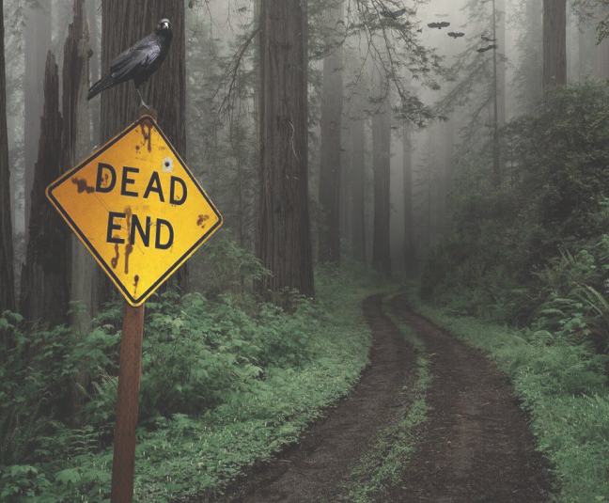  Write a story to say what happens next. Some suggestions are written below.  __________________________  36 people live in these 8 houses. Each house has a different number of people living in it. Each line of 3 houses has 15 people living in it.  How many people live in each house?  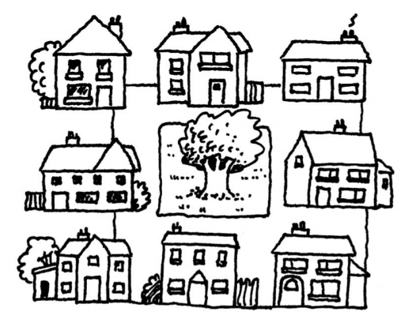  A possible answer is shown below. | Watch genuine footage of volcanic eruptions here:  https://www.youtube.com/watch?v=VBTAcACmcgo  Make your own volcanic eruption, using simple ingredients! Follow the instructions below!  ______________________  In 79AD Mount Vesuvius erupted in Pompeii. The ancient Romans wrote about what happened and the ruins of the town and even the remains of people who were living there at the time can still be seen today.  Research the Pompeii eruption here: https://kids.kiddle.co/Pompeii  ______________________  Architects in places where earthquakes happen design buildings that can shake without falling down!  Can you use connect sticks to make stable structures that can do the same? You could use toothpicks & raisins, but there are lots of alternatives!  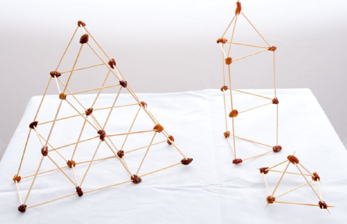  More guidance below!  ______________________  Earlier in the year we looked at Turner’s paintings of the sea. He was also fascinated by volcanoes and painted them: 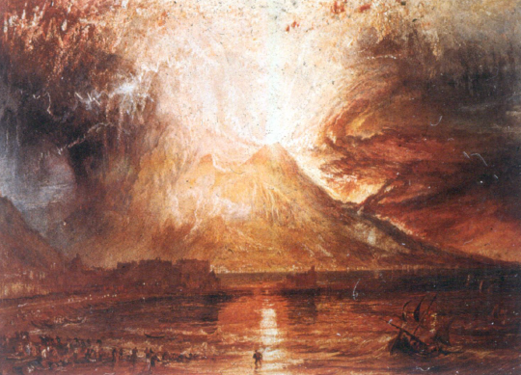  Draw your own version. Use paint if you have it to give the explosion the liquid look of real lava! | Choose a game from ixl.com - this week, I recommend ‘Show fractions: area models’:  https://uk.ixl.com/math/year-4/show-fractions-area-models  Easy? Explore some of the other games available on this website! Click on the words ‘Year 4’ to see all the games available.  _______________  Explore the Active Maths website: http://www.active-maths.co.uk/  Play a game on your own or with a partner - there's lots of challenges here!  _______________  Play the role of Mayor to save your town from the Mt Leakytop volcano. Install the seismometers and prepare the town for evacuation! https://www.cfa.harvard.edu/earthscope/volcano_island/  _______________  New one from here:  Make Op-Art spirals that’ll twist your eyes! Watch the tutorial to see how: https://www.youtube.com/watch?v=2EPLYkZdq2I | We’re all allowed to take exercise outdoors, once a day, as long as we can keep a safe distance from others.  The Daily Mile at Home offers easy, fun ideas for exercise activities for you and your family: https://thedailymile.co.uk/at-home/  _______________  Lava Carpet. In this classic game the children must leap from safe base to safe base without touching the ground as the floor is made of molten lava and will melt them on contact, sending them back to the start. Can be played outside or inside in any space big enough and what constitutes ‘the floor’ is up for debate - does a rug count?  _______________  Add a mathematical challenge to this game by putting times tables facts on each safe base that need to be correctly answered before the base can be used!  _______________  Follow an online yoga video at Cosmic Kids  cosmickids.com

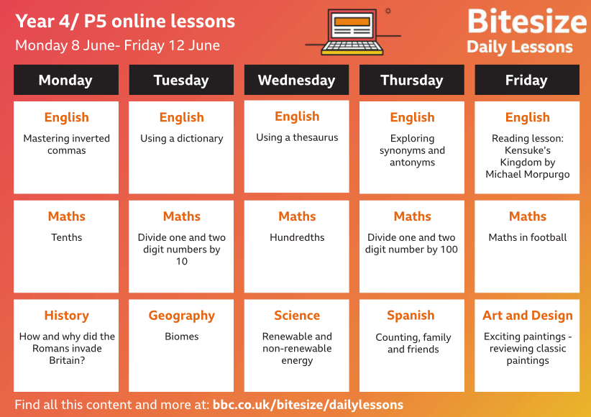

Story writing
Think about the following:
- What does the sign mean? Is that blood on the sign? Why might it be there?
- What is the weather like? How could that make your journey difficult?
- Why is the crow looking at you? Will it follow you or fly off?

Maths challenge
One possible answer is below:
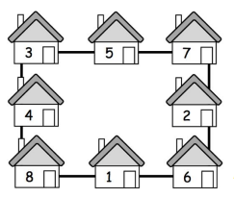

Making a volcano
There are lots of tutorials about how to perform this experiment online, but these instructions should get you there too!
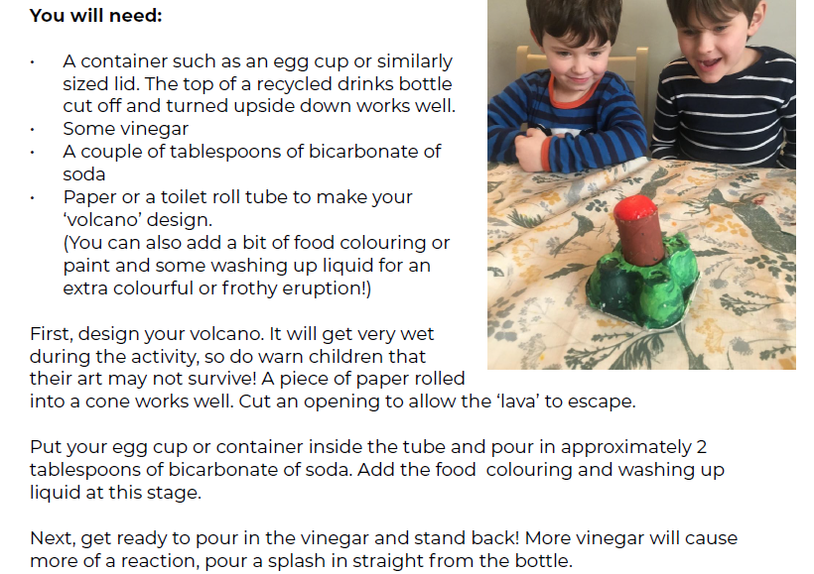

Make an earthquake resistant building

Houses and other buildings built in areas at risk of earthquakes have to be engineered so that they don’t crack and fall apart. Instead, the buildings sway with the movement of the earthquake and don’t break.

You can experiment with different types of structure using cocktail sticks (or spaghetti, though this is more brittle) held together with marshmallows or raisins.
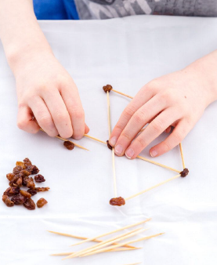

Does the height of the building make a difference? Are there some shapes that are stronger than others?

As an extra challenge, you could test your building by making a wobbly floor of jelly in a large dish. You can shake the buildings to see which are the strongest!

