Year 2 Learning Activities - Week Nine 18th May 2020
Please read through the choice of activities on the next page with your grown-ups and try to complete FOUR each day. Your parents/carers can send pictures of your learning or ask any questions via our email accounts:
helenbanks@st-bartholomews.brighton-hove.sch.uk
ianbeggs@st-bartholomews.brighton-hove.sch.uk
A day for the Y2 class at the moment could look like:
Time | What are we doing? | Activity choices
9.00 - 10.00 am | Active / Motivation Time | Join Joe Wicks - The Body Coach TV - youtube - for his daily workout or choose one of the activities in the pink boxes.
10.00 - 10.30 am | Reading Time | Read a book or your choice or choose an e-book on the OxfordOwls website  www.oxfordowl.co.uk/for-home/find-a-book/library-page
10.30 - 11.00 am | Learning Time | Play some Maths games online. Try:  coolmathgames.com  or  mathsframe.co.uk
11.00 - 12.00 pm | Learning Time | Choose one of the activities from the green boxes.
12.00 - 12.30 pm | Lunch | Help to make lunch, clean up and put everything away.
12.30 - 1.00 pm | Free Play
1.00 - 2.00 pm | Creative Time | Choose one of the activities in the yellow boxes.
2.00 - 3.00 pm | Innovation Time | Choose one of the activities in the blue boxes.
Good luck and keep in touch! We look forward to seeing what you have all been up to.
Learning  Time | Creative  Time | Innovation  Time | Motivation Time
Watch this video on lines of symmetry: https://www.bbc.co.uk/bitesize/clips/ztpyr82  Can you complete the castle themed line of symmetry pictures on the next page – remember each side must be a mirror image of each other.  ____________________________  Draw a picture of a castle, and then research and label it using these words:  flag, gatehouse, keep, bailey, curtain wall, battlements, moat, tower, portcullis, drawbridge.  ___________________________________  With an adult, read through and discuss the 'Castles Reading Comprehension'. Answer the questions on page 2, using information from the text.  ____________________________  Complete the ‘Mystery at Dragonspire Castle’ activity. Be prepared! To solve the mystery will require all of your amazing Maths skills!  _____________________________  BBC Bitesize are offering 3 daily lessons every day - online or on the BBC iPlayer. Have a look at this week's schedule and choose at least 3 activities that interest you.  This week's Maths videos are here:  https://whiterosemaths.com/homelearning/year-2/  The worksheets are on our school website Year 2 page. | Design your own coat of arms for a family shield. Think carefully about which colours you choose and the symbols you include in your design.  _________________________  Use some photographs and pictures of castles to do your own observational sketch of a castle. Remember to use different sketching techniques to make it look realistic – you could cross-hatch, hatch, stipple, or scumble!  _________________________  Make your own castle model. You could make this using Lego, recyclable materials or even playdough. Remember to include lots of detail such as the drawbridge, the moat, the tower and the portcullis. Take photographs of your model.  _________________________  Create a 'Topic dictionary' for all the key words linked to castles. Remember to include a brief description of what the word means and include a drawing.  _________________________  Create an acrostic poem about castles!  Remember to use adjectives to add detail and include words such as, flag, gatehouse, keep, bailey, curtain wall, battlements, moat, tower, portcullis, drawbridge. | Can you create a working catapult to defend your castle using elastic bands, lollipop sticks and a plastic spoon? Set up a Science experiment and see which of your catapult creations can send a piece of pasta or a grain of rice the furthest. Record your results in a table.  ____________________  Using your Common Exception Words can you create a new board game to help you practise these? You could make a game of spelling snap, spelling snakes and ladders or even spelling Uno! Play your game with your family.  ____________________  Write a set of rules for your castle that people must obey! Remember to write using command sentences – be bossy!  ____________________  Some castles had mazes outside them for people to solve. Draw and create your own maze for someone in your family  to complete. | Create a new game to play with your family outdoors in your garden or the park. Remember to keep it active!  _____________  Go on GoNoodle and complete a Zumba, Kidspop or BlazerFresh work out. (GoNoodle is free and you just need to sign up for an account)  https://app.gonoodle.com/  _____________  Can you complete a jigsaw puzzle at home? Draw a picture and create your own puzzle by cutting it into pieces – who in your house can solve your puzzle the quickest?

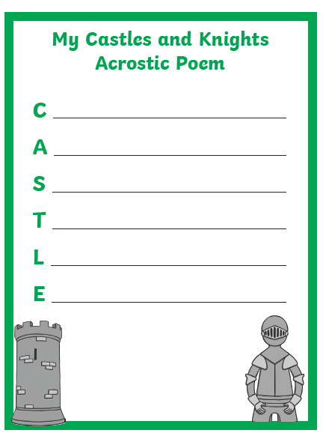

CASTLE LINE OF SYMMETRY PICTURES
