A day for the Y5 class at the moment could look like:
Time | What are we doing? | Activity choices
9.00-10.00am | Active / Motivate Time | Join Joe Wicks – The Body Coach TV – you tube –for his daily workout or choose one of the activities in the blue boxes.
10.00-10.30am | Reading Time | Read a Collins e-book https://collins.co.uk/pages/support-learning-at-home or choose one of the activities in the orange boxes.
11.00-12.00pm | Learning Time | Choose one of the activities in the green boxes.
12.00-12.30pm | Lunch | Help make lunch, set the table and put everything away.
12.30-1.00pm | Free Play | Have a rest and play with some toys or relax.
1.00-2.00pm | Creative Time | Choose one of the activities in the yellow boxes.
2.00-3.00pm | Learning Time | Choose one of the activities in the green boxes.

Learning Time | Creative Time | Active/Motivate time | Reading time
BBC Bitesize - There are daily English and Maths lessons as well as other subjects that might be a fun. Just click on the year 5 daily lessons.
https://www.bbc.co.uk/bitesize/dailylessons

SUPER SENTENCE STACKERS  9:45am  LIVE WRITING LESSONS!  www.youtube.com/c/thetrainingspace  THE LIGHTHOUSE ANIMATED SHORT FILM  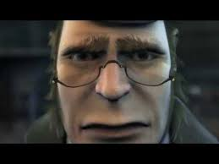  https://www.literacyshed.com/the-lighthouse.html  If you are able to, watch ‘The Lighthouse’. It can be found on the website of the Literacy Shed (above link) or it is available on YouTube.  Write a RECOUNT of the events. Remember it will be in the past tense as you describe what happened in your own words. Try to use some dramatic language.  WRITE A LETTER TO YOUR FUTURE SELF!  So the task is to tell your ‘future’ self all about you at the moment! You might want to include your favourite things, what you hope for the future, and any other interesting facts! Make sure you put the date on it as it will be an interesting read when you’re older. You might even want to draw a picture of yourself!  MATHS LESSON with  WHITE ROSE or BBC BITESIZE  www.whiterosemaths.com/homelearning/year-5/  The focus this week is on finding the area of rectangles and some fraction work. I’ve put a worksheet on the class page to have a go at involving improper fractions.  Watch the White Rose videos if you can and then have a look at the BBC Bitesize daily lessons.  MS SOAR’S MATH’S CHALLENGES:  How many rectangles or squares can you draw with an area of 36cm squared? Can you make any right-angled triangles with that area?  Remember:  Area = Length x width  Area of a right-angled triangle = (length x width) divided by 2 | SELF REFLECTION (because you’re all AMAZING!)  Look at the ‘I am an amazing person’ balloon sheet. I would like you to finish off the sentences in the balloons. If you would rather not print off the sheet, you could represent how amazing you are in your own way.  DRAWING CHALLENGE  Can you draw all 30 things on the list? They don’t need to be perfect, but they do need to be on one page. Be brave and explore! The list and instructions are below the grid. Take a photo of your completed challenges and email them to me! I’d love to see them.  BECOME A SINGER-SONGWRITER  You’ll need: your best music making skills!  Whether you want to be a solo artist or form a group with your family members, use this time to make up a song or rap! Pick a theme (or ask someone else to) and see if you can make a song or rap based on the theme.  Remember, anything can be a musical instrument, so get creative and figure out how to make music in a completely unique way.  DESIGN YOUR OWN HIDEOUS MONSTER!  Just like the Chimera in the Pegasus story, can you design your own hideous monster that might be made up of different creatures? You’ll can give it a cool name too:  Crocomonkey  Spiderzard  rhinorat | DAILY WALK  I am uploading Brighton and Hove’s outdoor learning ideas for this week. There are some lovely activities on here. I love the 21 objects game, the idea of snail races and the weaving with nature. Let me know if you manage to do any of these things.  SUSSEX SCHOOL GAMES  Has anyone had a go at the weekly activities?  www.sussexschoolgames.co.uk  GO NOODLE  YOGA - Cosmic Kids.  LEARN A DANCE ROUTINE WITH  OTI MABUSE – 11:30am | THE MAGIC FLYING HORSE - PEGASUS  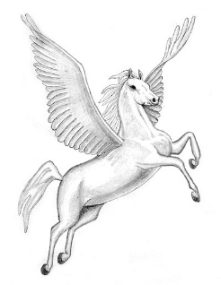  Read this Greek myth. It is only short and is on the Pangolin learning class page. Then choose to:  * Draw an image of the hideous monster, the chimera.  * Make a comic strip of the story. Remember to use speech bubbles.  *What do you think the moral of the story is? What messages is it trying to get across?  READ FOR 20 MINUTES EVERY DAY  If you are struggling to find something to read, please email me.  PANGOLIN READING CHALLENGE  Let me know when you have finished a book. I’d love to hear what you are reading.  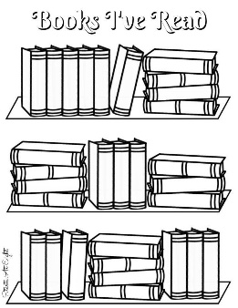  THE BOY, THE MOLE, THE FOX AND THE HORSE  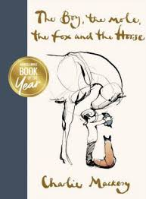  I am putting a link on our class learning page to this book. We have looked at it before, and it is simply stunning and quite relevant to our current times. There are 5 activities around this book, which I think we could dip in and out of over the next couple of weeks.
