Year 4 Learning Activities - Week Eight 11th May 2020

Please read through the choice of activities on the next page with your grown-ups and try to complete FIVE each day. Your parents/carers can send pictures of your learning or ask any questions via my email account:
ianbeggs@st-bartholomews.brighton-hove.sch.uk
A day for the Y4 class at the moment could look like:
Time | What are we doing? | Activity choices
9.00 - 10.00 am | Active / Motivation Time | Join Joe Wicks - The Body Coach TV - youtube - for his daily workout or choose one of the activities in the pink boxes.
10.00 - 10.30 am | Reading Time | Read a book or your choice or choose an e-book on the OxfordOwls website  www.oxfordowl.co.uk/for-home/find-a-book/librar y-page
10.30 - 11.00 am | Learning Time | Play some Maths games online. Try:  coolmathgames.com or  mathsframe.co.uk
11.00 - 12.00 pm | Learning Time | Choose one of the activities from the green boxes.
12.00 - 12.30 pm | Lunch | Help to make lunch, clean up and put everything away.
12.30 - 1.00 pm | Free Play
1.00 - 2.00 pm | Creative Time | Choose one of the activities in the yellow boxes.
2.00 - 3.00 pm | Innovation Time | Choose one of the activities in the blue boxes.

Good luck and keep in touch! We look forward to seeing what you have all been up to.

Learning  Time | Creative  Time | Innovation  Time | Motivation  Time
BBC Bitesize are offering 3 lessons every day - online or on the BBC iPlayer. Have a look at this week's schedule (on the next page) and choose at least 3 activities that interest you. If you can’t decide, I’ve put arrows by three that I recommend! __________________________  Watch and listen to the story of The Boy, The Mole, The Fox and The Horse, read by Tim Uffindell here: https://www.youtube.com/watch?v=81b4i9jQhck  After listening to it once, listen to the story a second time thinking about the questions below as you listen. Then answer the questions.  __________________________  These children have been kidapped!  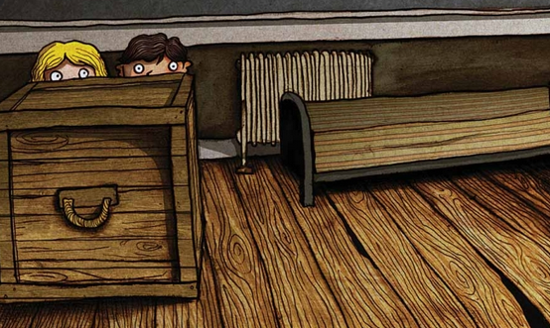  Write a story about their escape… Think about who could have taken them, why they were kidnapped, what they could use to get away, how they could get help and who from! __________________________  Complete a maths lesson from the ‘Summer term, week 4’ section here:  https://whiterosemaths.com/homelearning/year-4/ __________________________  Find 5 objects at home with square or rectangular faces. Measure the edges and use your measurements to calculate the perimeter and area of each. These formulas might help:  Perimeter = length1 + length2 + width 1+ width2  Area = length x width | Giuseppe Arcimboldo was an artist who liked to arrange vegetables into faces - see the picture below! If children are very careful and don’t damage the food, they could have a go at creating a picture too; they could also use pictures cut out from garden or food magazines if you have any available.  ______________________  How to chit potatoes: Chitting is just a word for getting a potato to sprout before planting it! It can be valuable for children to see that a potato left in a cool, dry place will eventually grow. It’s perfectly possible to get a crop of spuds from a supermarket potato! Here’s some advice from Monty Don on how to chit potatoes: https://www.gardenersworld.com/how-to/grow-plants/how-to-chit-potatoes/  ______________________  You can create great stamps to use with most child friendly ready mix paints using a simple potato. It works best if you cut the potato into the desired shape (be careful with sharp knives!) and then dry the surface a little on some paper before brushing on paint. When one layer of paint has dried, you can add others over the top (see pictures below). You can get good results with celery too!  ______________________  At the moment, we’re all grateful for the work of the NHS.  Research the life of a famous doctor or nurse. Draw them and add some of the information you discovered to the picture. | Choose a game from ixl.com - this week, I recommend Two Figures With the Same Area  https://uk.ixl.com/math/year-4/select-two-figures-with-the-same-area Easy? Explore some of the other games available on this website! Click on the words ‘Year 4’ to see all the games available.  _________________  A fruit has its seeds inside. A vegetable is a leaf or root that does not contain its seeds. But what is a berry? Research which foods, in scientific terms, are fruit, vegetables and berries. Did any surprise you?  _________________  Have a look at some of the graffiti art that children have submitted to the Tate Gallery on their website: https://www.tate.org.uk/kids/games-quizzes/street-art  Now click on ‘start’ to begin making your own. Explore using the rollers, spray paint and stickers before trying to use them to create a monster, alien, unicorn or a design of your own! _________________  Plants need 4 things to grow. Can you identify them? There’s a clip here that will help: https://www.bbc.co.uk/bitesize/topics/zy66fg8 | We’re all allowed to take exercise outdoors, once a day, as long as we can keep a safe distance from others.  The Daily Mile at Home offers easy, fun ideas for exercise activities for you and your family: https://thedailymile.co.uk/at-home/ ______________  Follow an online yoga video at Cosmic Kids  cosmickids.com  ______________  Try this call and response game while walking round the room or garden. The caller cries out ‘SEED!” and players have to curl up small on the floor. If the word called out is “STEM!” players stretch up as tall as they can, on their toes, arms in the air. For “BEES!” they all run around as fast as they can, making buzzing noises. You can invent extra commands too…

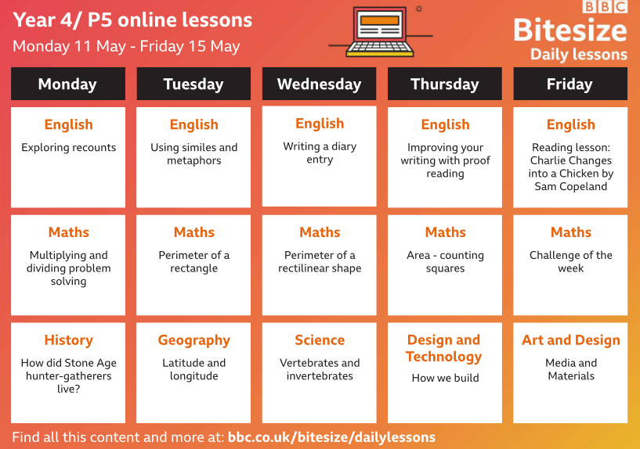

Giuseppe Arcimboldo:
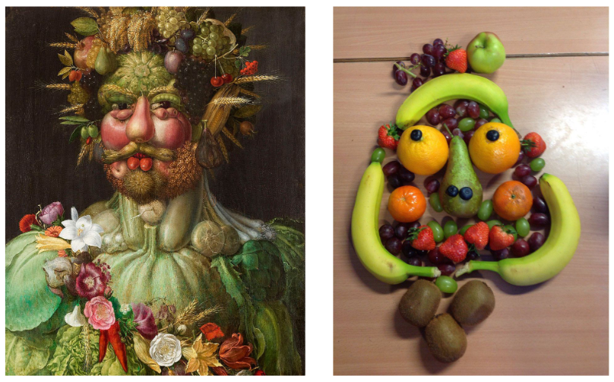

The Boy, The Mole, The Fox and The Horse:
Listen to the story through 1 time. Then, listen to the story again thinking about the questions below as you listen. Then answer the questions:
1. Why do you think the pages of this book have no numbers?
2. What is different about this book to others that you have read?
3. Look back over the book one more time and decide which is your favourite illustration. Say why you like this one best and what materials you think it is done with.
4. Look through the book and stop at this page. What impression do you get of the mole so far? Is he young or is he old? Give 2 pieces of evidence from the text or pictures to support your answer.
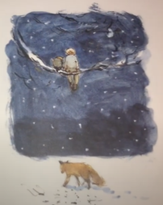
5. Look closely at the night time page above… What might it seem that the fox is doing when you first see the page?
6. Look at the next page:
a) What is a snare?
b) Who might have wanted to capture the fox with a snare and why?
7. Now let’s think about foxes….
a) How many other stories can you think of with foxes in them? List or draw them here:
b) What kind of characters are foxes usually given in stories and why do you think they are portrayed in this way?
c) What do you think the fox is like at this point in the story? Is he good or bad? Give evidence from the text or from the pictures.
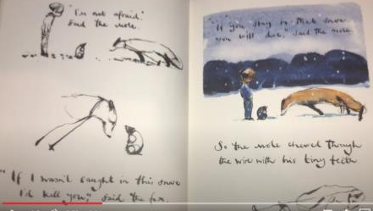
8. Why will the fox die if he stays in the snare?
9. Why do you think the Mole decided to save him?
Vegetable printing:
