Year 2 Learning Activities - Week Eight 11th May 2020
Please read through the choice of activities on the next page with your grown-ups and try to complete FOUR each day. Your parents/carers can send pictures of your learning or ask any questions via our email accounts:
helenbanks@st-bartholomews.brighton-hove.sch.uk ianbeggs@st-bartholomews.brighton-hove.sch.uk
A day for the Y2 class at the moment could look like:
Time | What are we doing? | Activity choices
9.00 - 10.00 am | Active / Motivation Time | Join Joe Wicks - The Body Coach TV - youtube - for his daily workout or choose one of the activities in the pink boxes.
10.00 - 10.30 am | Reading Time | Read a book or your choice or choose an e-book on the OxfordOwls website  www.oxfordowl.co.uk/for-home/find-a-book/librar y-page
10.30 - 11.00 am | Learning Time | Play some Maths games online. Try:  coolmathgames.com or  mathsframe.co.uk
11.00 - 12.00 pm | Learning Time | Choose one of the activities from the green boxes.
12.00 - 12.30 pm | Lunch | Help to make lunch, clean up and put everything away.
12.30 - 1.00 pm | Free Play
1.00 - 2.00 pm | Creative Time | Choose one of the activities in the yellow boxes.
2.00 - 3.00 pm | Innovation Time | Choose one of the activities in the blue boxes.

Good luck and keep in touch! We look forward to seeing what you have all been up to.

Learning  Time | Creative  Time | Innovation  Time | Motivation  Time
BBC Bitesize are offering 3 lessons every day - online or on the BBC iPlayer. Have a look at this week's schedule (on the next page) and choose at least 3 activities that interest you. If you can’t decide, I’ve put arrows by some that I recommend!  __________________________  Complete a maths lesson from the ‘Summer term, week 4’ section here:  https://whiterosemaths.com/homelearning/year-2/  __________________________  Write a story based on this picture:  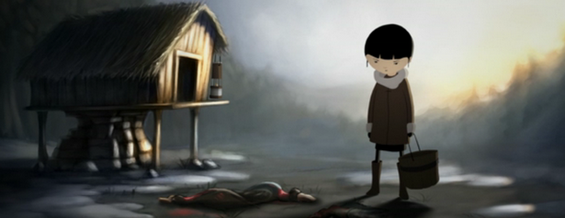  Why is the girl sad? What might cheer her up? Why is the house built off the ground? What is she carrying and why?  __________________________  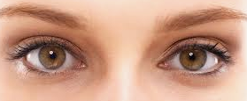  2+2+2=6 3x2=6  I’ve drawn three pairs of eyes and written a number sentence to explain. Notice that I’ve done it 2 ways: with addition AND with multiplication.  Draw five cars. How many wheels are there? Write both number sentences to explain. Try it with 3 cats (count the legs), 5 pyramids (the points) and 2 octopi (tentacles)! __________________________  Watch and listen to the story of The Boy, The Mole, The Fox and The Horse, read by Tim Uffindell here: https://www.youtube.com/watch?v=81b4i9jQhck  After listening to it once, listen to the story a second time thinking about the questions below as you listen. Then answer the questions. | Now that spring is here and everything is growing, this week’s lessons have a lot of plants in them.  Could you combine ingredients to turn a simple sandwich into a monster? Have a look at the examples below to get some ideas!  _______________________  Try an experiment to see how water is carried up the stem of a plant towards the leaves or flower. You will need: food colouring and celery (or a white flower - carnations work well). Place the flower or celery into a glass of water, coloured with food dye. A few drops should work, but the effect will be more noticeable if you add more. What is happening? Why do you think it is happening? Encourage your child’s suggestions. The celery is perfectly safe to eat afterwards!  _______________________  Lots of artists like to draw pictures of plants. Your child could make some drawings of their own. They might like to make a botanical drawing that is as realistic as possible, like a sketch you might find in a science book, or they might like to arrange some plants as a still life, or they could make up some completely imaginary plants and draw those! There are some images below to give you ideas!  _______________________  At the moment, we’re all grateful for the work of the NHS.  Research the life of a famous doctor or nurse. Draw them and write some of the information you discovered around the picture. | Choose a game from ixl.com - this week, I recommend Ways To Subtract From A Number:  https://uk.ixl.com/math/year-2/ways-to-subtract-from-a-number-subtraction-sentences  Easy? Explore some of the other games available on this website! Click on the words ‘Year 2’ to see all the games available. ________________  Match the flowers to their names using the Woodland Trust game here: http://www.treetoolsforschools.org.uk/activities/labelling/?act=lbl_woodland_flowers&id=0&col=1C8162&light=0&lcol=891C23&title=Woodland%20flowers  Try to beat your score! ________________  Create Word Art to illustrate The Boy, The Mole, The Fox and The Horse using this website:  https://wordart.com/create  Type key words in on the left and press ‘enter’ each time. Then, choose a shape, font & layout before clicking the red ‘visualise’ button to see your artwork! | Try this website for some motivating exercise fun:  https://www.gonoodle.com/  ______________  We’re all allowed to take exercise outdoors, once a day, as long as we can keep a safe distance from others.  The Daily Mile at Home offers easy, fun ideas for exercise activities for you and your family: https://thedailymile.co.uk/at-home/ ______________  Try this call and response game while walking round the room or garden. The caller cries out ‘SEED!” and players have to curl up small on the floor. If the word called out is “STEM!” players stretch up as tall as they can, on their toes, arms in the air. For “BEES!” they all run around as fast as they can, making buzzing noises. You can invent extra commands too…
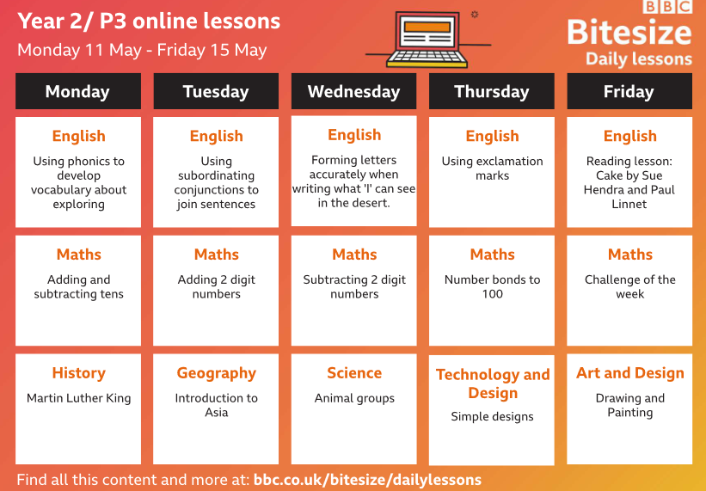

Monster sandwiches:
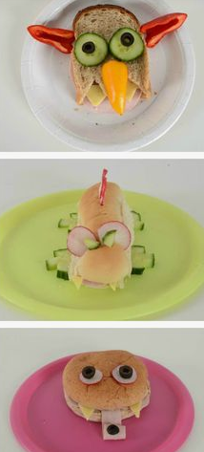

Drawing plants:
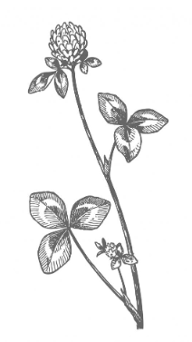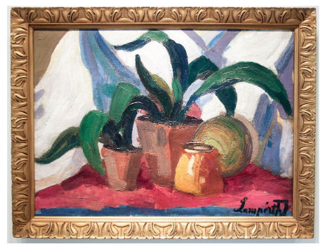

The Boy, The Mole, The Fox and The Horse:
1. Why do you think the pages of this book have no numbers?
2. Is there anything different about this book to others you have read?
3. Write or draw to show what you think the fox might be about to do on this page in the story:
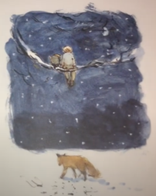
4. Look at this page:
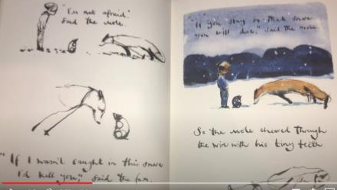
a) What do you think about the fox here? Is he being nice or is he being mean?
b) Why do you think the fox would die if he stayed in the trap?
c) Can you think of any other stories that have foxes in them? Draw or write about one.
d) Can you think of any fox characters that are good rather than bad?
5. What shape has the fox made with his feet? Why?
