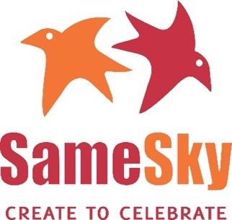
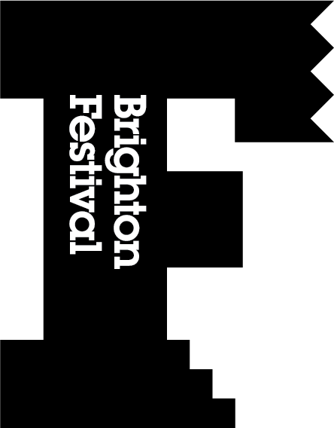
Join us to celebrate the Children’s Parade at Home

Let’s make this city sing this May and come together for creativity!

All of us at Brighton Festival and Same Sky were really disappointed that we could not have the magnificent Children’s Parade this May. But with your help we can still celebrate our children and their amazing creativity across the city in a new way.

This joyous celebration of creativity and imagination on the date the Parade would have taken place will bring together together thousands of children across Brighton & Hove in their own homes.

Children’s Parade at Home
Sat 2 May, 2020
10.30am (for about 5 minutes)
In your garden, your doorway, your window, your living room…anywhere that is safe.
Be creative, dress up, make some noise, takes some pictures and share your creativity with us. #childrensparadeathome

Special thanks to Tobias in Year 6 at Balfour Primary who asked his teacher to get in touch and see if the parade could still happen in this new fun and creative way!

What to do?
There are lots of ways you can take part depending on how much time you can spare.
- Dress up, make costumes, puppets, a mask, a headband, face paints
- Sing, shout, bang drums, play music, blow whistles (whatever you have at home to make a noise!)
- Dance, prance, and pose! Why not make up a routine?

We will help by sending you some inspiration from our Same Sky artists on creating trumpets, shakers and home-style makes from recycled materials. Look out for these coming soon, or head to brightonfestival.org or facebook.org/brightonfestival
Who can join in?
Anyone can take part! Tell your friends, family and neighbours, we want as many children to take part as possible, no age limit and children don’t even have to be a student of one of the schools that were planning to take part in the parade.

On the day
At 10.30 we will mark the event open by sharing some drumming herald, this is your cue to start the parade on our social media pages. Follow us, tag us and share your own photos and videos on the day so we can create a visual parade online and bring everyone together! #childrensparadeathome

Join the Parade event here: https://www.facebook.com/events/639017436635850/

If your child’s school has a Facebook page you can also tag them so we know which school they are from.

Brighton Festival
Facebook: @brightonfestival
Twitter: brightest
Instagram: brightonfestival
brightonfestival.org

Same Sky
facebook:@sameskyBtn
https://www.facebook.com/SameSkyBtn/
Twitter/Instagram: @sameskybtn

THANK YOU FOR TAKING PART!

Brighton Festival & Same Sky’s Children’s Parade is kindly sponsored by

