A day for the Y5 class at the moment could look like:
Time | What are we doing? | Activity choices
9.00-10.00am | Active / Motivate Time | Join Joe Wicks – The Body Coach TV – you tube –for his daily workout or choose one of the activities in the blue boxes.
10.00-10.30am | Reading Time | Read a Collins e-book https://collins.co.uk/pages/support-learning-at-home or choose one of the activities in the orange boxes.
11.00-12.00pm | Learning Time | Choose one of the activities in the green boxes.
12.00-12.30pm | Lunch | Help make lunch, set the table and put everything away.
12.30-1.00pm | Free Play | Have a rest and play with some toys or relax.
1.00-2.00pm | Creative Time | Choose one of the activities in the yellow boxes.
2.00-3.00pm | Learning Time | Choose one of the activities in the green boxes.

Learning Time | Creative Time | Active/Motivate time | Reading time
BBC BITESIZE : https://www.bbc.co.uk/bitesize/dailylessons

SUPER SENTENCE STACKERS  9:45am  LIVE WRITING LESSONS!  www.youtube.com/c/thetrainingspace  Has anyone tried this yet?  I WISH – TALK FOR WRITING BOOKLET  https://www.talk4writing.com/wp-content/uploads/2020/05/Y5-One-Chance.pdf  The link will take you to the booklet, but I am also putting the document on the class page for you to look at. I would like to see if any of you could write your own version of:  ‘My mirror of wishes’ (page 6) or ‘My mirror of despair!’ Or both!  Follow the instructions in the book leading up to this, but don’t go beyond page 6.  MATHS LESSON with  WHITE ROSE or BBC BITESIZE  www.whiterosemaths.com/homelearning/year-5/  The focus this week is on:  *Multiplying fractions  *Fractions of an amount  *Using fractions as operators.  Watching the video will help you to understand the methods used to answer the questions.  THIS CAN BE TRICKY TO UNDERSTAND, SO PLEASE EMAIL ME IF YOU NEED HELP!  Fractions is a big part of the Year 5/6 curriculum, so it’s good to try to be confident with them.  MS SOAR’S MATH’S CHALLENGES:  Choc bars cost 26p each.  Fruit bars cost 18p each.  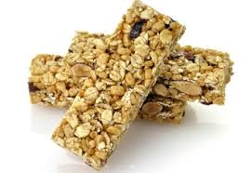  Ms Blood spent exactly £5 on a mixture of choc bars and fruit bars. How many of each did she buy? | DAILY ACTS OF KINDNESS  Look at the tick sheet I have attached. How many of the daily acts of kindness can you tick off in a day? Have a go at doing these every day. Are some easier to do than others? Have you ticked every box by Friday? Which has the most ticks? Send me your completed tick lists!  Challenge: Some of you might be able to store the data/information in another way. If you have MS Excel, you could have a go at recording it on a spreadsheet!  BOOK SIGN CHALLENGE  If you have any cardboard lying around, or any wood(!) have a go at making your own book signs. I would love to display these in the classroom reading area or library when we get back to school. Here are some fantastic examples. Choose your favourite books to put on the signs.  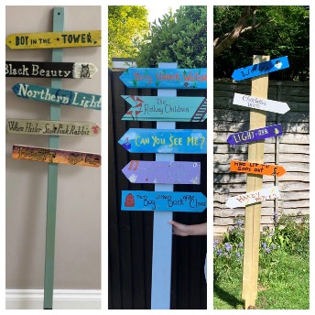  I’ve attached a bigger example of this under the grid.  NUMBER ONE SONGS  Can you find out what song was number one in the charts on the day you were born?  Listen to it. What are the lyrics about?  Mine is ‘Rivers of Babylon’ by Boney M, which I really do not like!  Do you like it? | DAILY WALK  On your daily walk, can you make a map of your local area? Look for road names, and key buildings. Then have a look on google maps. You might be able to see your home, the school, or somewhere you have travelled to further afield!  NATURE CHALLENGE  When you are outside, what birds do you see? Can you name them all? Keep a tally chart of the ones that you see and how often you see them. I have attached a chart of different birds you may see to the class page.  YOUTH SPORTS TRUST  www.youthsporttrust.org/60-second-physical-activity-challenges  Take a look at their website if you can as they have lots of challenges online.  I am attaching the ‘Around the World’ challenge and the ‘Speed Bounce’ challenge. Let me know how you get along! | GOOD/BAD REVIEW LANGUAGE  I want you to grab a big piece of paper. Then draw a line down the middle. One side will be good review language, the other side will be bad review language. THEN go onto Amazon, or Goodreads. Look at the REVIEWS. Make a note of language used for Great reviews (5*) and really bad reviews (1*)  READ FOR 20 MINUTES EVERY DAY  I am challenging myself to read my height in books by the end of 2020. How many books do you think you can read by the end of year 5? Send in photos of you reading in your favourite places – the funnier the better!  AUDIBLE  Download Rooftoppers by Katherine Rundell for free. Let me know if you enjoy listening to it.  PANGOLIN READING CHALLENGE  Did anyone read a good book over the half term? Let me know. My top 5 reads of lockdown are:  The boy, the mole, the fox and the horse – Charles Makesey  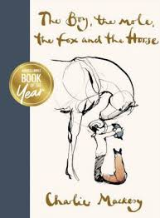  Rooftoppers – Katherine Rundell  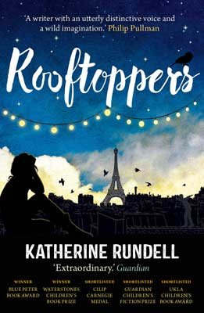  I don’t like Poetry – Joshua Seigal  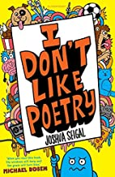  Icarus was ridiculous – Pamela Butchart  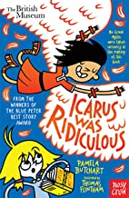  There’s a star outside my window – Onjali Q Rauf  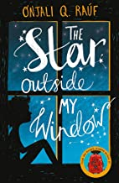  Can you design a new front cover for your favourite book?
