|  |  |  |  |
| --- | --- | --- | --- |
| Click on the **blue writing** to go straight to the website. | |  |  |
| Learning Time | Creative Time | Active / Motivate Time | Reading Time |
| **The First Tear**  After reading [**‘The First Tear’**](https://literacytrust.org.uk/family-zone/9-12/book-hopes/) by Kevin Crossley-Holland pg. 285 from The Book of Hopes, I’d like you to:   * Create your own short creation story about how a first thing was created. * It could be ‘The First Laugh’ or ‘The First Song.’ * The last paragraph has to begin, ***‘And since then, …’*** | **The World from My Window**  Have a look at the drawing below by Lauren Child from [**‘The Book of Hopes’**](https://literacytrust.org.uk/family-zone/9-12/book-hopes/), the inspiration behind this piece of art-work.   1. I want you to draw a self-portrait of yourself looking out of a window at home. Have a look at Rob Biddulph’s self-portrait guide [**here**](http://www.robbiddulph.com/draw-with-rob)to help. 2. Then draw what you can see directly out of that window. 3. Have a look at the drawing and think about where you could add a small amount of colour.   **Cooking Time**  I have made banana and peanut butter ice-cream this week as I had 3 bananas that needed using.  Can you make something delicious only using 3 ingredients? | **Percentages–**  **[Super movers](https://www.bbc.co.uk/teach/supermovers/ks2-maths-calculate-percentages-with-the-worst-witch/zr9njhv)**  Try this great work out of your body and brain.  Do not forget to use bullet points in your penguin fact file.  **2.6 Challenge**  Do you want to take part in the 2.6 challenge?  Have a look [**here**](https://www.bbc.co.uk/newsround/52419127) to see if you can. | **Reading into Writing**  Read [**‘The First Tear’**](https://literacytrust.org.uk/family-zone/9-12/book-hopes/) pg. 285 from The Book of Hopes.  Read [**‘Me’**](https://literacytrust.org.uk/family-zone/9-12/book-hopes/) pg. 291 from The Book of Hopes. |

|  |  |  |
| --- | --- | --- |
| A day for the Y6 class at the moment could look like: | | |
| Time | What are we doing? | Activity choices |
| 9.00-10.00am | Active / Motivate | Join Joe Wicks – The Body Coach TV – you tube –for his daily workout or choose one of the activities in the blue boxes. |
| 10.00-10.30am | Reading Time | Read a Collins e-book <https://collins.co.uk/pages/support-learning-at-home> or choose one of the activities in the orange boxes. |
| 11.00-12.00pm | Learning Time | Choose one of the activities in the green boxes. |
| 12.00-12.30pm | Lunch | Help make lunch, set the table and put everything away. |
| 12.30-1.00pm | Free Play | Have a rest and play with some toys or relax. |
| 1.00-2.00pm | Creative Time | Choose one of the activities in the yellow boxes. |
| 2.00-3.00pm | Learning Time | Choose one of the activities in the green boxes. |

**Jaguars Learning Activities – Week 7**

Please read through the choice of activities with your grown-ups. Your parents / carers can send pictures of your learning or ask any questions via my email account: [fionakeeling@st-bartholomews.brighton-hove.sch.uk](mailto:fionakeeling@st-bartholomews.brighton-hove.sch.uk)

Star’s chorus from ‘The Only Way is Up’ x

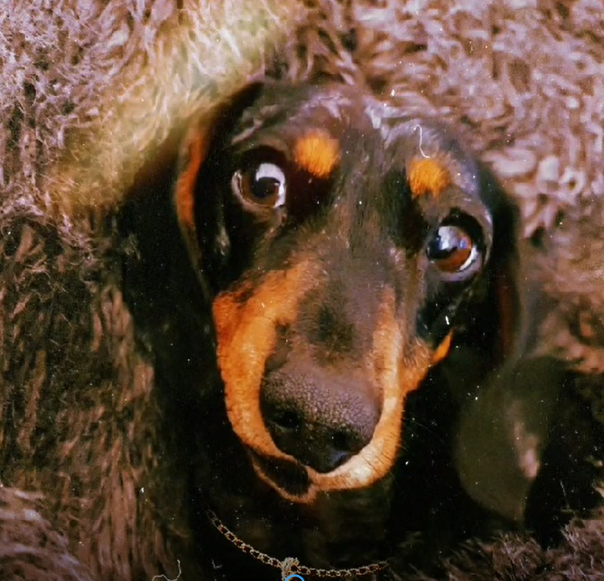

|  |  |  |  |
| --- | --- | --- | --- |
| **Me**  After reading [**‘Me’**](https://literacytrust.org.uk/family-zone/9-12/book-hopes/) by Swapna Haddow pg. 291 from The Book of Hopes, I’d like you to:   * Think about all the reasons that you love yourself. * Write a poem in the style of ‘Me’ beginning with the line, ***I Love me…***   **Daily Maths Lesson**  Complete a daily maths lesson from  [**White**](https://whiterosemaths.com/homelearning/) rose.  or  [**iseemaths**](http://www.iseemaths.com/lessons56/)  **Story Starter**  Finish the story…  *Peeking through the window, her surprise turned to horror…*  **Percentages**  Practise your percentage knowledge [**here.**](https://www.bbc.co.uk/bitesize/topics/znjqtfr)  **PSHE**  Look at this scenario below and use as many words as you can on the emotive language mat to persuade them not to throw your teddy away.  ***Your parent / carer wants to throw away your old teddy. You’ve had the teddy since you were a baby, however it is falling to pieces; it has no eyes and looks scary. Persuade them to let you keep it.*** | **Drawing a Dinosaur**  Try drawing a Gregosaurus with Rob[**here.**](http://www.robbiddulph.com/draw-with-rob) If you send me photos of your drawing then I’ll send them to Rob Biddulph.  **Cooking Time**  I’d like you to cook something super healthy for a yummy dinner. | **PE with YOU**  Create your own 10-minute workout in the style of Joe Wicks. Test it out on the people at home.  [**Just Dance**](https://www.youtube.com/channel/UChIjW4BWKLqpojTrS_tX0mg)  Get everyone in your house joining in with your favourite just dance song!  **PE with Joe’s wife!**  Joe has had an operation so on Monday his wife will be following his moves [**here.**](https://www.youtube.com/channel/UCAxW1XT0iEJo0TYlRf) | **Little Red Riding Hood**  Next week, we are starting a project on Fairy tales so I’d like you to listen to the **[audible version of Little Red Riding Hood.](https://stories.audible.com/pdp/B07CLF4TBX?ref=adbl_ent_anon_ds_pdp_pc_pg-1-cntr-0-0)**  **The Magic of Empathy Masterclass**  Listen to Cressida Cowell talk about how empathy helps us work together, by discovering the magic of putting yourself in another person’s shoes [**here.**](https://www.worldbookday.com/online-masterclasses/the-magic-of-empathy/)  **Book Quiz**  Try this [**quiz**](C://Users/fkeel/OneDrive/Desktop/Book%20Quiz.pdf) and see how much you know about children’s books.  **First News**  Enjoy reading the latest edition of First News. We will be doing some work on the articles next week. |