Learning Time | Creative Time | Active / Motivate Time | Reading Time
Writing Flashbacks  Look at this image. Write a story beginning with this image then flash back to how she ended up there.  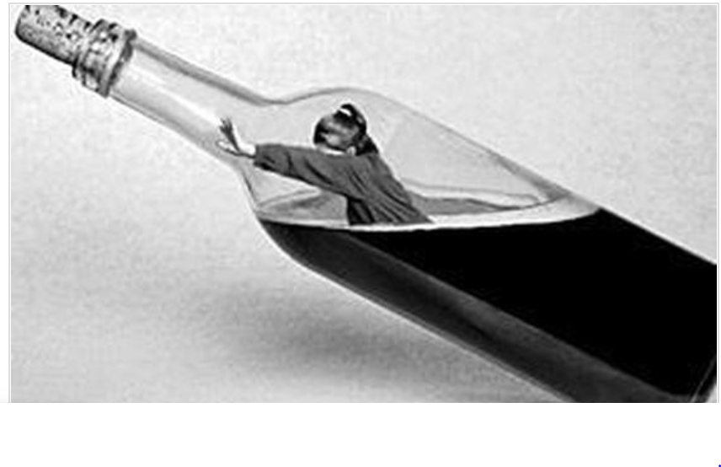 | Create a world for Star  Use the image of Star above and place her somewhere by drawing a background. Imagine all of the places that she could be!  Cooking Time  With the help of an adult, can you create a new recipe and cook something for dinner out of the resources you have. Remember not to waste anything!  Make an origami dachshund  Follow this link to make a miniature Star. Send me photos and Star will judge them.  https://www.youtube.com/watch?v=p2tGLIhRXv8 | PE with Joe  I am doing this every morning and it’s fun but my legs hurt!  Go Noodle – Try Strengthen your focus  https://family.gonoodle.com/  Yoga  Follow an online yoga video with Cosmic Kids. | The Boy in the Striped Pyjamas  I have put the whole text on the website for you in the Jaguar’s page. Spend 30 minutes every day and finish reading the book.  We will do some writing based on it next week.  I’d love to hear who finishes it first. Don’t forget to email me and let me know!  Elevenses with ‘The World of David Walliams’  Tune in at 11am to hear a story read by David.  BOOK IN A BOX  Can you create your favourite book in a shoe box? Here is an example of

Jaguars Learning Activities – Week 2
Please read through the choice of activities with your grown-ups. Your parents / carers can send pictures of your learning or ask any questions via my email account: fionakeeling@st-bartholomews.brighton-hove.sch.uk
A day for the Y6 class at the moment could look like:
Time | What are we doing? | Activity choices
9.00-10.00am | Active / Motivate Time | Join Joe Wicks – The Body Coach TV – you tube –for his daily workout or choose one of the activities in the blue boxes.
10.00-10.30am | Reading Time | Read a Collins e-book https://collins.co.uk/pages/support-learning-at-home or choose one of the activities in the orange boxes.
11.00-12.00pm | Learning Time | Choose one of the activities in the green boxes.
12.00-12.30pm | Lunch | Help make lunch, set the table and put everything away.
12.30-1.00pm | Free Play | Have a rest and play with some toys or relax.
1.00-2.00pm | Creative Time | Choose one of the activities in the yellow boxes.
2.00-3.00pm | Learning Time | Choose one of the activities in the green boxes.

Learning Time | Creative Time | Active / Motivate Time | Reading Time
Daily Maths Lesson  Complete a daily maths lesson from  whiterosemaths.com/homelearning/  or  www.iseemaths.com  Science – Red Wolves  Learn about these beautiful, rare animals. Use the Red Wolf resource on the website to investigate red wolves. Can you create a similar fact sheet for an animal of your choice?  Story Starter  Bleary-eyed, I went downstairs for breakfast; the house was empty and even the furniture had gone. It all started a week ago….  Complete the story in only 500 words! | Draw with Rob Biddulph  http://www.robbiddulph.com/draw-with-rob  Learn to draw like a professional illustrator – this is great fun and of course there is a sausage dog in one of them! | PE with YOU  Create your own 10 minute work out in the style of Joe Wicks. Test it out on the people at home. | Quiz Time  Can you guess the book titles I’m referring to in these crossword-style clues?  - Voids in the ground  - Yorkshire illuminations  - The king of the jungle and a sorceress battle in a cupboard  - Tic tac toe  - Which would you prefer?  - Writing a letter to a menagerie  - Owlets  - The journal of a timid/weak child  - There’s an ogre on the phone for you  - Between the end of day and the start of night  - Prince William’s brother (his proper name) is just dreadful!  - Eternally  - Maybe later, Bernie  - Multiples of one thousand thousands  - Old tat  - A wise bird dinner set  - One time only  - Small birds and women warriors  - It was me who made the fortress my prisoner  - This man is a creamy off-white popular paint colour

