A day for the Y5 class at the moment could look like:
Time | What are we doing? | Activity choices
9.00-10.00am | Active / Motivate Time | Join Joe Wicks – The Body Coach TV – you tube –for his daily workout or choose one of the activities in the blue boxes.
10.00-10.30am | Reading Time | Read a Collins e-book https://collins.co.uk/pages/support-learning-at-home or choose one of the activities in the orange boxes.
11.00-12.00pm | Learning Time | Choose one of the activities in the green boxes.
12.00-12.30pm | Lunch | Help make lunch, set the table and put everything away.
12.30-1.00pm | Free Play | Have a rest and play with some toys or relax.
1.00-2.00pm | Creative Time | Choose one of the activities in the yellow boxes.
2.00-3.00pm | Learning Time | Choose one of the activities in the green boxes.

Learning Time | Creative Time | Active/Motivate time | Reading time
LIVE WRITING LESSONS!  Write a story with the whole country! Join @janeconsidine each morning at 9:45am and write a chunk of the story. She’ll pick some to be part of the final story.  Subscribe to the You tube channel  www.youtube.com/c/thetrainingspace  I honestly cannot rate this highly enough. Nine sentences and a fabulous teacher showing you how to do it!  Email me any of your writing pieces.  FREE WRITING  Some fabulous images and story openers for you to continue on:  www.pobble365.com  Just choose a day where the image grabs you to write a paragraph or 2.  DIARY  Keep up with or begin to write a diary entry for each day, using your most beautiful handwriting. It only has to be few sentences.  MATHS LESSON  Complete a daily maths lesson from  www.whiterosemaths.com/homelearning/year-5/  or  www.iseemaths.com  White Rose are doing some fabulous Easter practical Maths activities each day. Have a look!  https://whiterosemaths.com/homelearning/easter-fun/  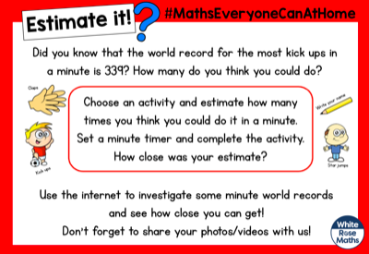  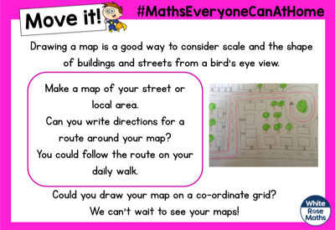  LITTLE MATH’S CHALLENGE:  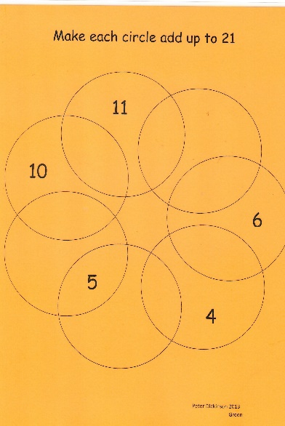  Use the numbers below in the diagram above to make each circle add up to 21.  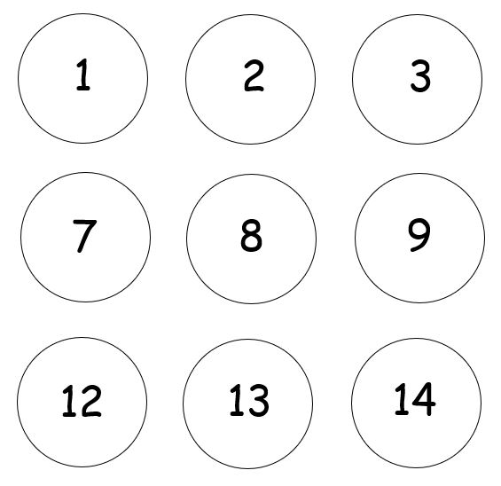  This will get your brain’s going! Try doing this with a grown up. It is not easy! | BIKE IT DRESS UP!  The Bike-It team have prepared a bike- blinging up challenge for us! Have a look at the extra document that I’ve sent out this week. Decorate your bike, scooter or skateboard. If you don’t have one, choose a toy from home to decorate or dress up!  ART JUMPSTART  Check out the artist Darrell Wakelam. He can be found on Twitter with some of his amazing art sculptures to make out of old egg boxes or toilet rolls. Grab some scissors and tape, follow his instructions and off you go! I’d love to see some of your creations! They look like a lot of fun. Here are a couple of examples, but there are lots to choose from!  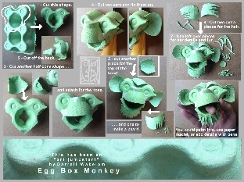  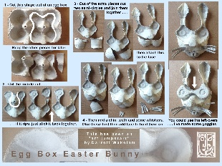  LEARN FROM THE ILLUSTRATORS!  Check out Jim Field, Rob Biddulph, Lydia Monks and Stephen Lenton. They have some AMAZING online tutorials. I loved doing Sonic the Hedgehog with Rob Biddulph on Friday! Send in your Sonics!  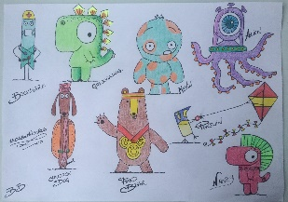  THE WONDERFUL CHARLES MACKESY  The Boy, the Mole, the Fox and the Horse, is a collection of empowering sentiments and beautiful illustrations.  Look at this page. What to you is better than cake? Can you answer the question and produce an illustration to go with it?  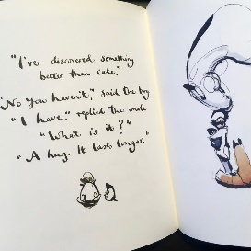 | YOGA  Follow an online yoga video with Cosmic Kids.  LEARN A DANCE ROUTINE WITH  OTI MABUSE – 11:30am daily.  Oti Mabuse from ‘Strictly come Dancing’ and ‘The greatest Dancer’ is doing daily dance lessons for children on Youtube. I highly recommend these!  CHALK ACTIVITY COURSE  If you have any chalk available, make up a fun activity course outside your home, in your garden or a pathway on your daily walk. It will be lots of active fun for you, your family and others to enjoy.  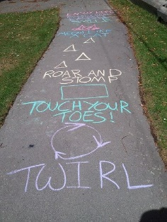  ANDY MURRAY’S 100 VOLLEY CHALLENGE  British tennis player, Andy Murray, has set up the 100 volley home challenge. If you have a racquet and ball, how many volleys can you do with a family member, or how many keepy ups can you do with a racquet and ball on your own? You could adapt this to a bat and ball, or keepy ups with a football. Or throws and catches with somebody without dropping the ball! Let me know how you get on! | BEETLEBOY BY M.G.LEONARD  Did you manage to read the first chapter? If not, then go for it! It’s on the Pangolin page. It’s brilliant!  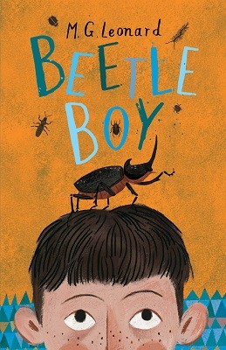  Then choose one of the following activities:  ART - After looking at the cover and reading Chapter One, draw what you think Darkus, Uncle Max and his dad look like.  WRITE: a missing person’s poster describing key details (i.e. 5Ws - Who, what, when, where, why) of the disappearance.  If you love it (as much as I did) then you could always download the audible version for free or check out the library’s BORROWBOX service. Plus it is 99p to download on the KINDLE at the moment!  READ EVERY DAY  Make sure you read something that you enjoy for at least 20 minutes each day. If you are struggling to find something to read, please, please email me.  SHOW ME WHAT YOU’RE READING!  Send me a photo of what you are reading! I would love to see the books you are enjoying! Books I have read in the last few weeks that I highly recommend are:  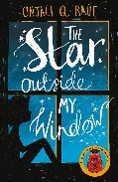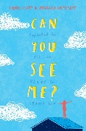  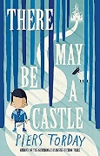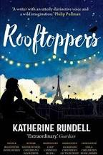  Lose yourself in a book!  STORYTIME WITH DAVID WALLIAMS  11am every day.

