**Henri Rousseau**

Henri Julien Félix Rousseau was a French post-impressionist painter. He painted many pictures of rainforests.



Star’s impression of Howler Monkeys in the Rainforest!

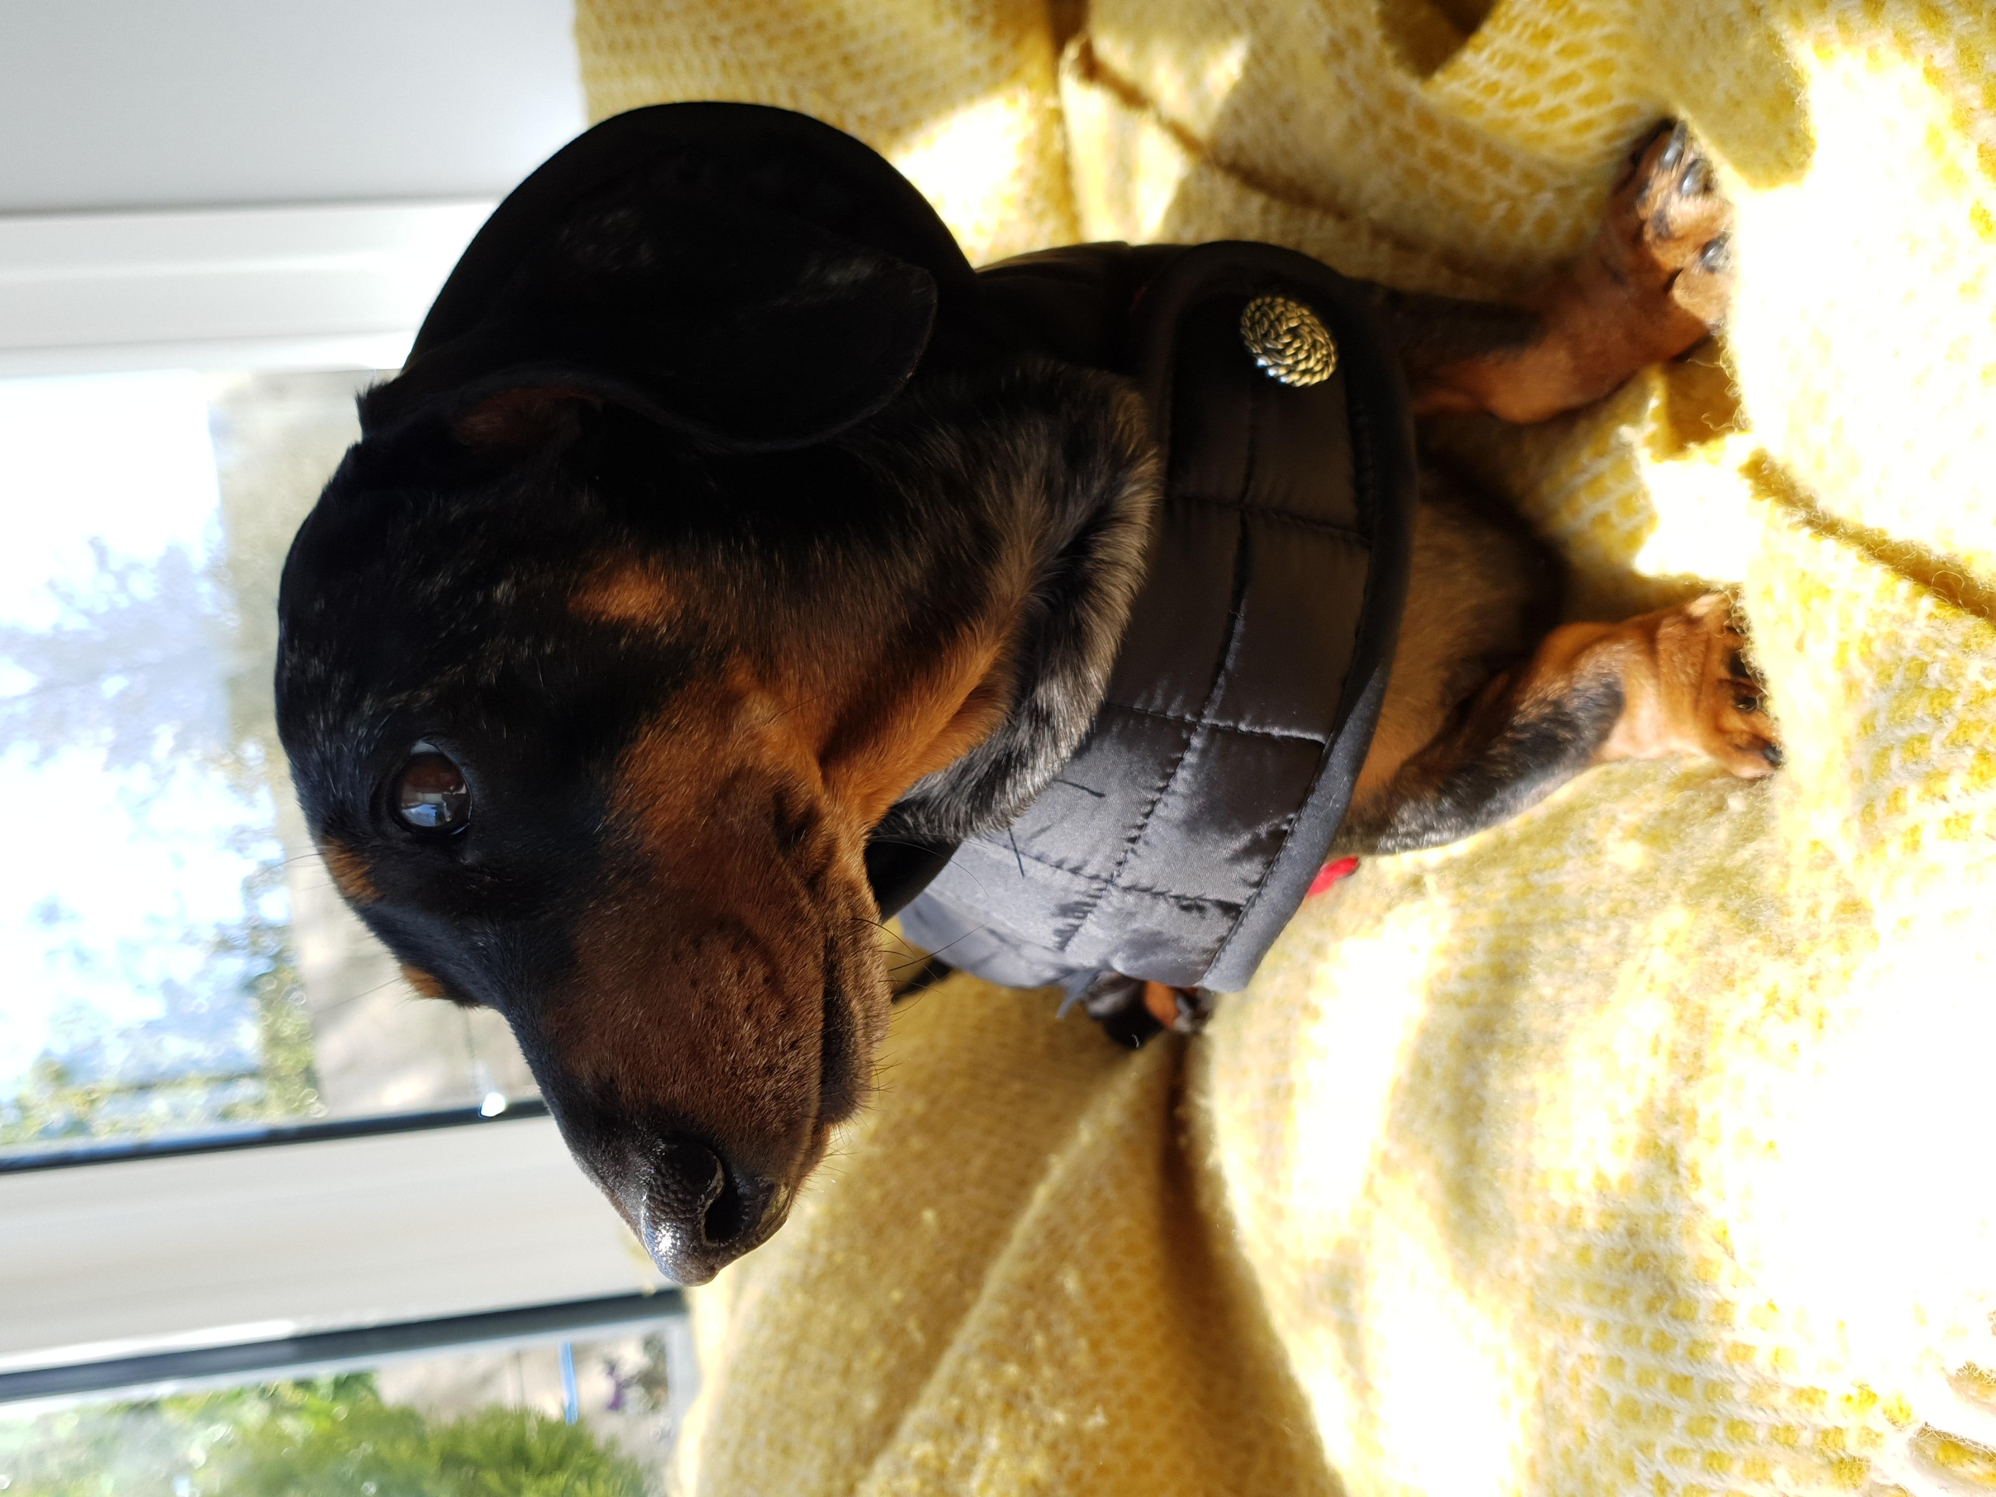

|  |  |  |  |
| --- | --- | --- | --- |
| Click on the **blue writing** to go straight to the website. | |  |  |
| Learning Time | Creative Time | Active / Motivate Time | Reading Time |
| **There’s a Rang-Tan in my Bedroom**  Watch the video, [**There’s a Rang-Tan in my bedroom.**](https://www.youtube.com/watch?v=3Ha6xUVqezQ) Now investigate Orangutans on the [**WWF site**](https://www.worldwildlife.org/species/orangutan)**.** What is palm oil and why is it used?   1. Create a poster to explain what using palm oil does to the rainforest and, orangutans. 2. Write a poem based on ‘There’s a Rang-Tan in my Bedroom’, using another rainforest animal, e.g. ***‘There’s a Jaguar in my Classroom.’*** | [Henri Rousseau Toucan (With images) | Henri rousseau, Art, Henri ...](https://www.google.co.uk/url?sa=i&url=https%3A%2F%2Fwww.pinterest.com%2Fpin%2F509610514086475888%2F&psig=AOvVaw3HWQI_OnzwmH7nTozGMgZ1&ust=1591638951666000&source=images&cd=vfe&ved=0CAIQjRxqFwoTCOjpx6Sj8OkCFQAAAAAdAAAAABAD)  Can you re-create the famous painting of a Toucan by Rousseau? | **PE with Joe**  Keep going with Joe every day.  **Stretching**  Stretch It is essential to give your body a good stretch, especially after exercising. Have a go at some body stretches using [**Cosmic Yoga.**](https://www.youtube.com/user/CosmicKidsYoga) | **The Explorer by Katherine Rundell**  Read the [**whole book here**](https://play.google.com/books/reader?id=VPS4DgAAQBAJ&hl=en_GB&pg=GBS.PT5) over the week.  **The Explorer Front Cover**  Imagine that you are an illustrator and you have been asked to design a front cover for The Explorer.  Design your front cover. |

|  |  |  |
| --- | --- | --- |
| A day for the Y6 class at the moment could look like: | | |
| Time | What are we doing? | Activity choices |
| 9.00-10.00am | Active / Motivate | Join Joe Wicks – The Body Coach TV – you tube –for his daily workout or choose one of the activities in the blue boxes. |
| 10.00-10.30am | Reading Time | Read a Collins e-book <https://collins.co.uk/pages/support-learning-at-home> or choose one of the activities in the orange boxes. |
| 11.00-12.00pm | Learning Time | Choose one of the activities in the green boxes. |
| 12.00-12.30pm | Lunch | Help make lunch, set the table and put everything away. |
| 12.30-1.00pm | Free Play | Have a rest and play with some toys or relax. |
| 1.00-2.00pm | Creative Time | Choose one of the activities in the yellow boxes. |
| 2.00-3.00pm | Learning Time | Choose one of the activities in the green boxes. |

**Jaguars Learning Activities – Week 11 – *It’s all about the Rainforest!***

Please read through the choice of activities with your grown-ups. Your parents / carers can send pictures of your learning or ask any questions via my email account: [fionakeeling@st-bartholomews.brighton-hove.sch.uk](mailto:fionakeeling@st-bartholomews.brighton-hove.sch.uk)

|  |  |  |  |
| --- | --- | --- | --- |
| **Fred’s Diary Entry from ‘The Explorer’**  Put yourself in Fred’s shoes. You have just survived a plane crash and landed in a strange and dangerous place. Write a diary entry to explain how you are feeling. Try to use elements of your environment to reﬂect your emotions.  **Survival Kit**  What important things do we need in order to survive if we were stranded in the rainforest? Write your own survival list!  **The Amazon**  Use the information found [**here**](https://www.wwf.org.uk/where-we-work/amazon?ds_rl=1263542&pc=ATC001002)to create a poster about WHY we need the Amazon.  **Rainforest Animal Superheroes**  Choose one of the animals on **[Rainforest Animals website](https://ypte.org.uk/factsheets/rainforest-animals/introduction?gclid=EAIaIQobChMIxvfeuejv6QIVh-7tCh0CEwaMEAAYAiAAEgI-H_D_BwE)**[. Research this animal and turn them into a superhero using the sheet on the website.](https://ypte.org.uk/factsheets/rainforest-animals/introduction?gclid=EAIaIQobChMIxvfeuejv6QIVh-7tCh0CEwaMEAAYAiAAEgI-H_D_BwE)  **Daily Maths Lesson**  Complete a daily maths lesson from  [**White rose**](https://whiterosemaths.com/homelearning/year-6/)**.** The resources are now on the  School Website. | **How to Draw a Jaguar**  Learn how to draw a Jaguar [**here**](https://www.youtube.com/watch?v=W8_Yu5WSkBo)https://www.youtube.com/watch?v=W8_Yu5WSkBo    **Cooking Time**  Create a recipe that is connected to the rainforest in some way! Check that you are not using any products that contain palm oil.  **Drawing a Blue-footed Booby**  Enjoy drawing a blue-footed booby with Rob [**here.**](http://www.robbiddulph.com/draw-with-rob)    [BirdLyfe: The Blue-Footed Booby - WildArk Journal - Medium](https://www.google.co.uk/url?sa=i&url=https%3A%2F%2Fmedium.com%2Fwildark-journal%2Fbirdlyfe-the-blue-footed-booby-7c4f5cd2bc58&psig=AOvVaw3okOJy_odoWITcPdJZnRZC&ust=1591623053693000&source=images&cd=vfe&ved=0CAIQjRxqFwoTCMCaw4fo7-kCFQAAAAAdAAAAABAD) | **Noun Phrases**  **[Super movers](https://www.bbc.co.uk/teach/supermovers/ks2-english-noun-phrases/zf7b6v4)**  Try this great work out of your body and brain.  Do not forget to use bullet points in your penguin fact file.  **Plank challenge**    See if you can hold the plank position for 20 seconds. | **The Explorer – Reading Comprehension**  Complete the reading comprehension on the website based on The Explorer by Katherine Rundell. |