A day for the Y5 class at the moment could look like:
Time | What are we doing? | Activity choices
9.00-10.00am | Active / Motivate Time | Join Joe Wicks – The Body Coach TV – you tube –for his daily workout or choose one of the activities in the blue boxes.
10.00-10.30am | Reading Time | Read a Collins e-book https://collins.co.uk/pages/support-learning-at-home or choose one of the activities in the orange boxes.
11.00-12.00pm | Learning Time | Choose one of the activities in the green boxes.
12.00-12.30pm | Lunch | Help make lunch, set the table and put everything away.
12.30-1.00pm | Free Play | Have a rest and play with some toys or relax.
1.00-2.00pm | Creative Time | Choose one of the activities in the yellow boxes.
2.00-3.00pm | Learning Time | Choose one of the activities in the green boxes.

Learning Time | Creative Time | Active/Motivate time | Reading time
Check out what BBC Bitesize have produced. There are daily English and Maths lessons as well as other subjects that might be a lot of fun. Just click on the year 5 daily lessons.
https://www.bbc.co.uk/bitesize/dailylessons

SUPER SENTENCE STACKERS  LIVE WRITING LESSONS!  Write a chunk of story and learn from the expert teacher Mrs Considine. Become a ‘Super Sentence Stacker’! Learn from the master!  Subscribe to the You tube channel  www.youtube.com/c/thetrainingspace  I think this is one of the best home learning writing sessions there is. It really sharpens up your writing skills.  Email me any of your writing pieces.  THE HEADTEACHERS’S OFFICE WRITING  After reading Chapter One of ‘Who Let The Gods Out?’ can you:  Write a conversation between a naughty pupil and a headteacher in the style of Elliot and Mr Boil. Use shifts in formality to make it effective.  FREE WRITING  Some fabulous images and story openers for you to continue on:  www.pobble365.com  Just choose a day where the image grabs you to write a paragraph or 2.  MATHS LESSON with  WHITE ROSE  This week it is all about decimals, so it will be fabulous practise. Look out for the challenge on Friday.  www.whiterosemaths.com/homelearning/year-5/  MS SOAR’S MATH’S CHALLENGE:  Can you list all the SQUARE NUMBERS less than 200?  Or (and this is a bit trickier), can you work out all the PRIME NUMBERS less than 100? | CREATE YOUR OWN MASK  Can you create your own Picasso style mask of a Greek God or Goddess out of cardboard?  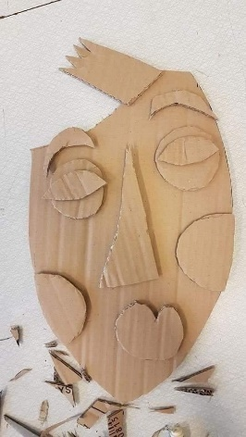  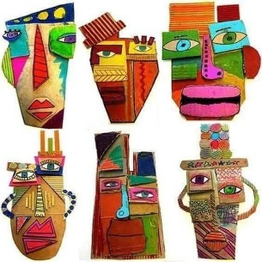  These look so bright and beautiful. The crazier and bolder the better! Pritt stick works absolutely fine to stick the card. Email me your creations.  LEARN FROM THE ILLUSTRATORS!  Check out Jim Field, Rob Biddulph, Lydia Monks and Stephen Lenton.  PAPER AEROPLANES  With just an A4 piece of paper, what is the furthest you can throw a paper aeroplane from a standing position?  Record your distances.  Show me some of yours and your family designs!  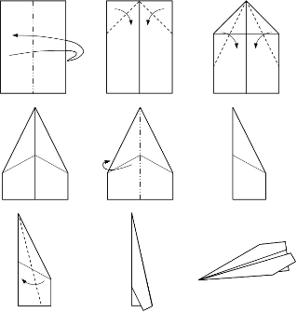  BODY BEATS  Online body percussion workshops. These don’t require any instruments, but if you’ve got rhythm and fancy a go at body percussion, these look really good.  Weekdays at 11am  https://www.youtube.com/user/OllieTunmer/videos  SAMESKY CHILDREN’S PARADE  Mr Beggs is sending information out about this by PING. The suggestion is that on May 2nd, when the Children’s parade was due to happen, we all dress up at 10:30am and make a lot of noise for about 5 minutes! Essentially having your own mini parade at home! | GO NOODLE  These songs are catchy, there’s no doubt about it. But they are fun! Look up the Go Noodle songs and dances on You Tube. ‘Banana, banana, meatball’ looks like one that may drive the grown-ups slightly mad!  YOGA  Follow an online yoga video with Cosmic Kids.  LEARN A DANCE ROUTINE WITH  OTI MABUSE – 11:30am daily.  These are really good if you are an average to confident dancer!  DAILY WALK  On your daily walk with a grown up, remember to be careful with social distancing, but can you take photos of things you see beginning with the letter ‘A’ on Monday, ‘B’ on Tuesday, ‘C’ on Wednesday etc. Or you could just take a piece of paper and pen out with you to jot them down. I have to say ‘A’ is really hard! | WHO LET THE GODS OUT? BY  MAZ EVANS  This is what I am reading at the moment.  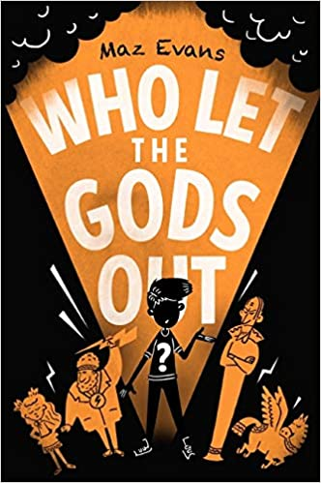  Read the first chapter of the book. It is very funny and actually the more you read of the book, the funnier it gets!  Then have a go at the following activities:  *READING COMPREHENSION  Read with a grown up or on your own and either –  * chat about your answers to the questions  *make a poster of your answers  * write the answers.  (see questions below.)  AUDIBLE version is free.  The library’s BORROWBOX service is free.  KINDLE DOWNLOAD is 99p.  READ FOR 20 MINUTES EVERY DAY  If you are struggling to find something to read, please, please email me.  SHOW ME WHAT YOU’RE READING!  Send me a photo of what you are reading! I received some good photos/book choices last week.

WHO LET THE GOD’S OUT? BY MAZ EVANS
CHAPTER ONE READING COMPREHENSION

- What does the author mean when referring to the body odour as ‘weapons grade’?

- What does ‘jubilantly’ mean? Can you do an impression of ‘lumbering jubilantly’?

- Is Elliot often in trouble? How do you know?

- Why do you think Mr Boil has no respect for Call Me Graham?

- Is Elliot a good student? How do you know?

- Where does Elliot go to school?

- How old is Elliot?

