Year 2 Learning Activities - Week Eleven 1st June 2020
Please read through the choice of activities on the next page with your grown-ups and try to complete FOUR each day. Your parents/carers can send pictures of your learning or ask any questions via our email accounts:
helenbanks@st-bartholomews.brighton-hove.sch.uk ianbeggs@st-bartholomews.brighton-hove.sch.uk
A day for the Y2 class at the moment could look like:
Time | What are we doing? | Activity choices
9.00 - 10.00 am | Active / Motivation Time | Join Joe Wicks - The Body Coach TV - youtube - for his daily workout or choose one of the activities in the pink boxes.
10.00 - 10.30 am | Reading Time | Read a book or your choice or choose an e-book on the OxfordOwls website  www.oxfordowl.co.uk/for-home/find-a-book/librar y-page
10.30 - 11.00 am | Learning Time | Play some Maths games online. Try:  coolmathgames.com or  mathsframe.co.uk
11.00 - 12.00 pm | Learning Time | Choose one of the activities from the green boxes.
12.00 - 12.30 pm | Lunch | Help to make lunch, clean up and put everything away.
12.30 - 1.00 pm | Free Play
1.00 - 2.00 pm | Creative Time | Choose one of the activities in the yellow boxes.
2.00 - 3.00 pm | Innovation Time | Choose one of the activities in the blue boxes.

Good luck and keep in touch! We look forward to seeing what you have all been up to.

Learning  Time | Creative  Time | Innovation  Time | Motivation  Time
Have a go at all of the BBC Maths lessons this week! As well as the daily Maths lessons, choose some extra ones that interest you. If you can’t decide, I’ve put arrows by ones that I recommend!  https://whiterosemaths.com/homelearning/year-2/  Worksheets & answers can be found on the Koalas page of the school website. __________________________  Write a story about what happens next (there’s a bigger version of the picture below).  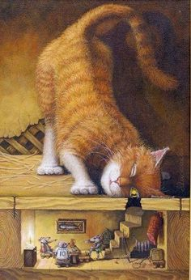  Think about how the cat found the mice, what the mice are saying to each other, what the cat could do next and how the mice could help each other.  __________________________  You will need up to 13 counters, pebbles or small objects and a 5 x 5 grid.  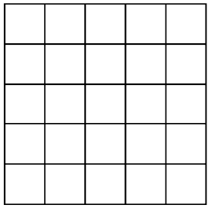  1) Place all 13 counters. You must have an odd number of counters in each row and column, as well as the two main diagonals.  2) Place 10 counters. This time you must have an even number of counters in each row and column, as well as the two main diagonals.  __________________________  There are 2 main ways to spell the ‘ow’ sound: ow and ou. How many words can you collect that use each of these spellings? | Make a recyclosaurus! With an adult, choose some items from your recycling to build a dinosaur with. Look at the photos below to get an idea how you could do this!  _______________________  What are electrical devices and how do they get the power to work?  Look around your home and find 5 devices that get their power from a battery and 5 that get their power from a plug.  But where does the power in the plug come from? Watch this clip to find out: https://www.bbc.co.uk/teach/class-clips-video/primary-science-how-is-electricity-made/zfhfgwx  _______________________  Use a dish, tray or even a whole area of your garden to make a miniature world for toy dinosaurs to live in (if you don’t have any toy dinosaurs, you can make a home for your recyclosaurus to live in). Using pebbles, moss, small plants and rocks, you can build your own land of the dinosaurs!  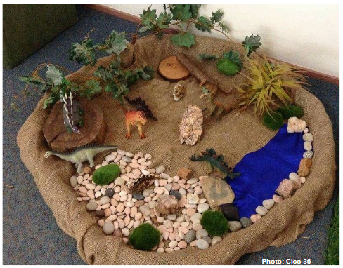  _______________________  Draw a dance routine to practice. Here’s an example:  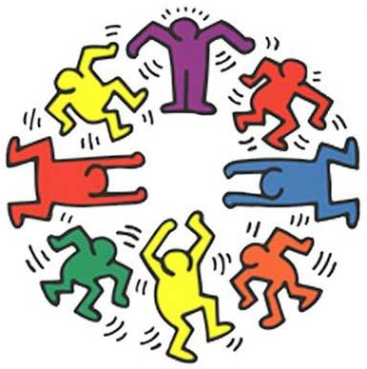 | Choose a game from ixl.com - this week, I recommend Count Equal Groups:  https://uk.ixl.com/math/year-2/count-equal-groups  Easy? Explore some of the other games available on this website! Click on the words ‘Year 2’ to see all the games available. _______________  Look around the house to identify the electrical dangers, using the website here: http://www.switchedonkids.org.uk/electrical-safety-in-your-home  Can you think of any others?  _______________  Explore the dinosaur directory at the Natural History Museum’s website: https://www.nhm.ac.uk/discover/dino-directory.html  What dinosaur only ate plants, has a name that begins with an ‘o’ and was found in China?  The museum isn’t sure what some dinosaurs ate! How many dinosaurs aren’t they sure about? | Try this website for some motivating exercise fun:  https://www.gonoodle.com/  _______________  We’re all allowed to take exercise outdoors, once a day, as long as we can keep a safe distance from others.  The Daily Mile at Home offers easy, fun ideas for exercise activities for you and your family: https://thedailymile.co.uk/at-home/ _______________  Dinosaur Spikes:  In this game, each player has a number of clothes pegs pegged to the back of their t-shirt like the spikes on the back of a dinosaur. The aim of the game is to unpeg as many of your opponents’ pegs as possible. When a player manages to take a spike from someone’s back, they can peg it on to the front of their t-shirt. Pegs cannot be stolen from people’s fronts. When the game ends, whoever has the most spikes is the winner!

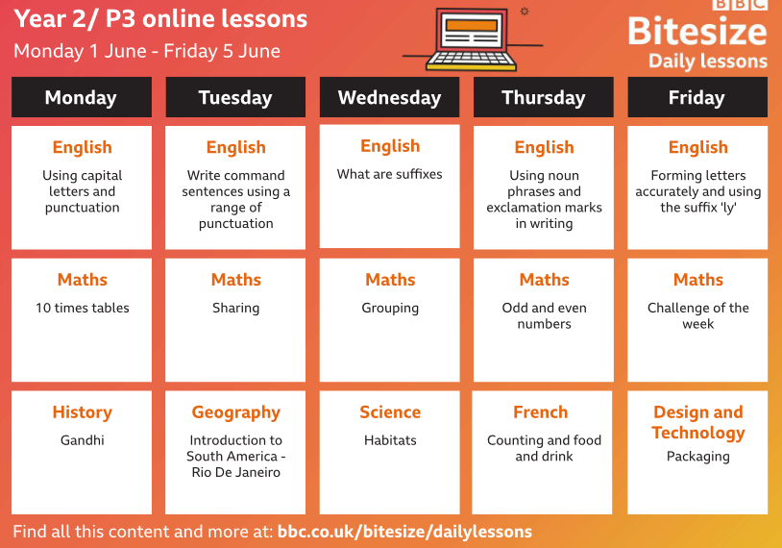

Story writing

Make a recyclosaurus:
Draw a the brontosaurus shape as shown and cut it out carefully with scissors, asking for help if you need it. Fold the head and tail sections down, as shown. Paint your dinosaur and add details such as eyes or scales.

