Yr 2 Koalas Learning Activities – Thursday 22.10.20 and Friday 23.10.20
Please read through the activities with your grown-ups. Your parents/carers can send pictures of your learning or ask any questions via our email accounts:
keelyallaway@st-bartholomews.brighton-hove.sch.uk
lisabeavis@st-bartholomews.brighton-hove.sch.uk

Hi Koalas!!!

We hope you and your families are well.

Here is some work to keep you busy over the next two days. We hope to see you in school after half term.
Best wishes and take care,

Miss Beavis.

English | Maths | Topic | Motivation
Thursday  Look at the “Shape Poetry” PowerPoint and then complete your own shape poem either using the shape poetry templates or create your own!  Friday  Look at the “What can you see In Autumn PowerPoint” complete the “In Autumn I See” sheet describing what you can see in Autumn.  Reading  Please complete the reading comprehensions on toys.  Try to read for at least 10 minutes each day! Either read to your grown up or listen to them reading to you!  Phonics  Thursday and Friday  Practise your blending. Go to https://www.phonicsplay.co.uk/resources/phase/3/picnic-on-pluto  If phase 3 is too easy try phase 4 or 5. | This week's Maths is all about addition and subtraction.  Thursday  Look at the “addition to 20” PowerPoint then complete the number bond sticks to 20 worksheet.  Friday  Look at the “subtraction to 20” PowerPoint then complete the subtraction from 20 worksheet.  Extra Maths?  Complete the addition and subtraction from 20 colouring activity.  Play some Maths games online. Try:  Cool Math Games https://www.coolmathgames.com  or  Maths Frame https://www.mathsframe.co.uk | Art  Do some leaf rubbings. Create some leaf pictures or leaf paintings.  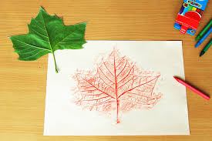  . 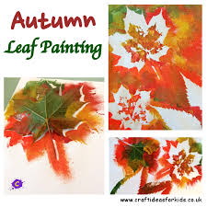  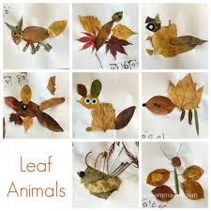  Art  We’ve been drawing self-portraits. Draw yourself as a superhero! What skills would you have?  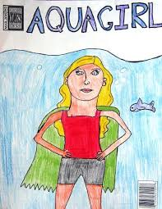 | Try to run the daily mile https://thedailymile.co.uk/at-home/  Get comfy and read a book on Epic!  https://www.getepic.com/  or  Read a Collins e-book https://collins.co.uk/pages/support-learning-at-home  Fancy some yoga? Go to  https://www.youtube.com/watch?v=GjP9KH8JT5Y

