Year 4 Learning Activities - Week Nine 18th May 2020

Please read through the choice of activities on the next page with your grown-ups and try to complete FIVE each day. Your parents/carers can send pictures of your learning or ask any questions via my email account:
ianbeggs@st-bartholomews.brighton-hove.sch.uk
A day for the Y4 class at the moment could look like:
Time | What are we doing? | Activity choices
9.00 - 10.00 am | Active / Motivation Time | Join Joe Wicks - The Body Coach TV - youtube - for his daily workout or choose one of the activities in the pink boxes.
10.00 - 10.30 am | Reading Time | Read a book or your choice or choose an e-book on the OxfordOwls website  www.oxfordowl.co.uk/for-home/find-a-book/librar y-page
10.30 - 11.00 am | Learning Time | Play some Maths games online. Try:  coolmathgames.com or  mathsframe.co.uk
11.00 - 12.00 pm | Learning Time | Choose one of the activities from the green boxes.
12.00 - 12.30 pm | Lunch | Help to make lunch, clean up and put everything away.
12.30 - 1.00 pm | Free Play
1.00 - 2.00 pm | Creative Time | Choose one of the activities in the yellow boxes.
2.00 - 3.00 pm | Innovation Time | Choose one of the activities in the blue boxes.

Good luck and keep in touch! We look forward to seeing what you have all been up to.

Learning  Time | Creative  Time | Innovation  Time | Motivation  Time
Have a go at all of the BBC Maths lessons this week! As well as the daily Maths lessons, choose some extra ones that interest you. If you can’t decide, I’ve put arrows by ones that I recommend!  https://whiterosemaths.com/homelearning/year-4/  Maths worksheets & answers can be found on the Penguins page of the school website. __________________________  The Boy, The Mole, The Fox and The Horse, part 2. https://www.youtube.com/watch?v=81b4i9jQhck  After listening to the story again, answer the set of questions, below.  __________________________  Think about this picture:  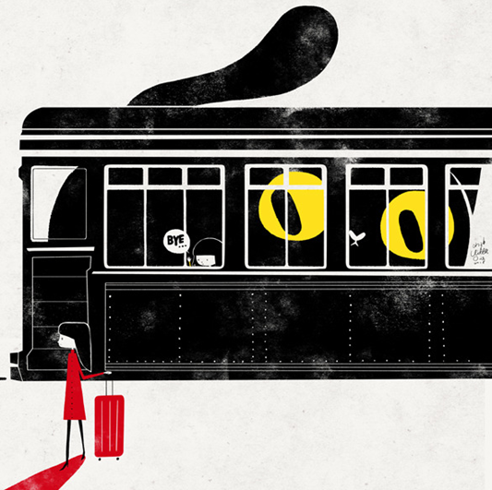  Write a story to explain what happens. Think about why the girl is on the bus, why nobody else is on it, what the giant cat might do and what the lady might be looking at.  __________________________  Ask an adult for some food that can be easily cut into pieces. Weigh the food in grams. Cut it in half and then predict the weight of each piece. Weigh the pieces to check your accuracy. Try again by cutting the halves into quarters, etc – predict the weight of each fraction each time. When the pieces get too small, eat them! | Make a life-cycle turning wheel following the instructions below. Look at how the lifecycle of a butterfly has been illustrated, then discover the lifecycle of a frog by watching the clip here: https://www.youtube.com/watch?v=AMs3waaW75g  Show the frog’s transition through all 4 stages on your turning wheel.  ______________________  Make a habitat guessing game. Fold a piece of paper to make a little ‘book.’ Draw a habitat on the outside an inside draw the creatures that live there. Make 3 of these little books and see which of your family can work out what’s inside. You could add some clues if needed.  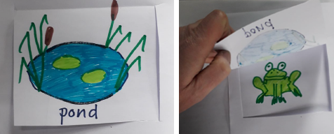  ______________________  Dogs are being trained to use their super sense of smell to help test people for the coronavirus.  What powers would you give an animal? Draw a picture of a super-powered animal – it could be your own pet - and add captions to explain what abilities it has, what it can do with them, how it got those powers and how you would like to reward it.  ______________________  Try to master Cat’s Cradle, following the tutorial here: https://www.youtube.com/watch?v=ZM53k3pKCqg  Can you manage the solo version? | Choose a game from ixl.com - this week, I recommend Fraction Review:  https://uk.ixl.com/math/year-4/fraction-review Easy? Explore some of the other games available on this website! Click on the words ‘Year 4’ to see all the games available.  _________________  Explore the Active Maths website: http://www.active-maths.co.uk/  Play a game on your own or with a partner - there's lots of challenges here!  _________________  Do you know where each animal should live? Why do they live there? Play the habitat game here to find out:  https://368.stem.org.uk/Human%20and%20Animal%20Habitats/page/modules/habitats2.html  _________________  Some animals have such a dramatic impact on their habitats that, if they are removed (by being hunted for example) the whole habitat can change! Find out about the impact animals can have on their habitat. Research the following creatures and try to find out why they are so important to their environment.  - Beavers  - Parrotfish  - Sea Otters | We’re all allowed to take exercise outdoors, once a day, as long as we can keep a safe distance from others.  The Daily Mile at Home offers easy, fun ideas for exercise activities for you and your family: https://thedailymile.co.uk/at-home/ ______________  Follow an online yoga video at Cosmic Kids  cosmickids.com  ______________  A change of pace game that’s best in the garden or when you go out for your daily trip to the park! Establish different movements for each animal. The sloth moves very, very slowly. The kangaroo jumps and the cheetah sprints as fast as it can. Other animals can be used too – frog, . One person takes it in turn to call out the different animals whilst everyone else does the actions.

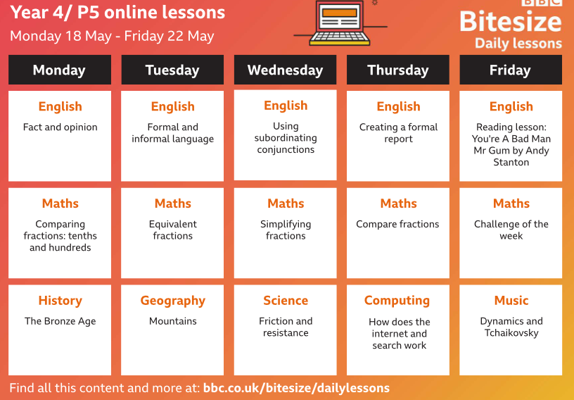

The Boy, The Mole, The Fox and The Horse, pt 2:
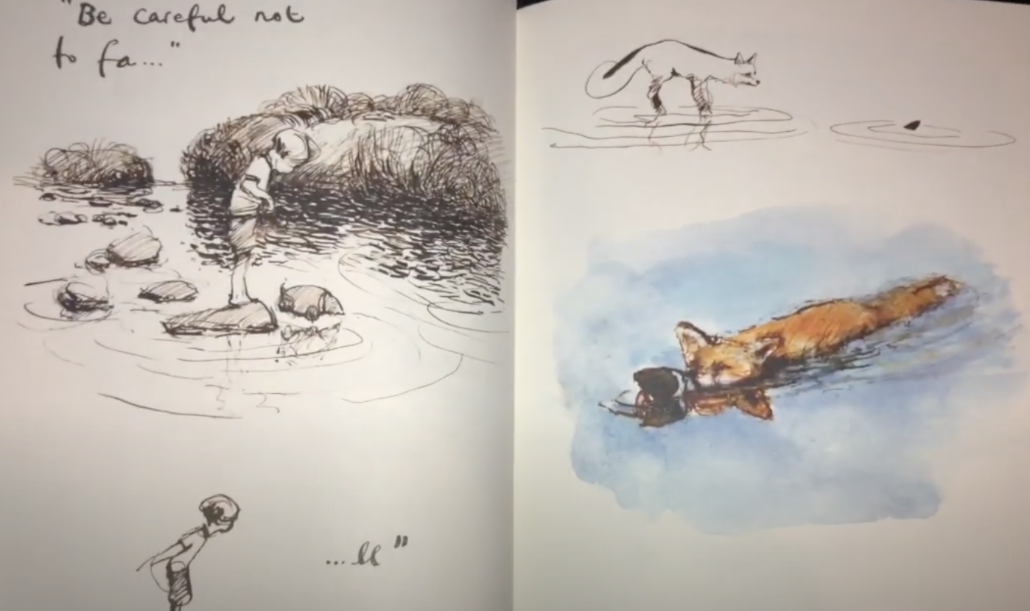
Listen to the story through again. Stop at this page:

- Now what do you think of the fox? Has your view changed? If so why has it changed?
- Why do you think the fox rescued the mole?
- Look at the next page.
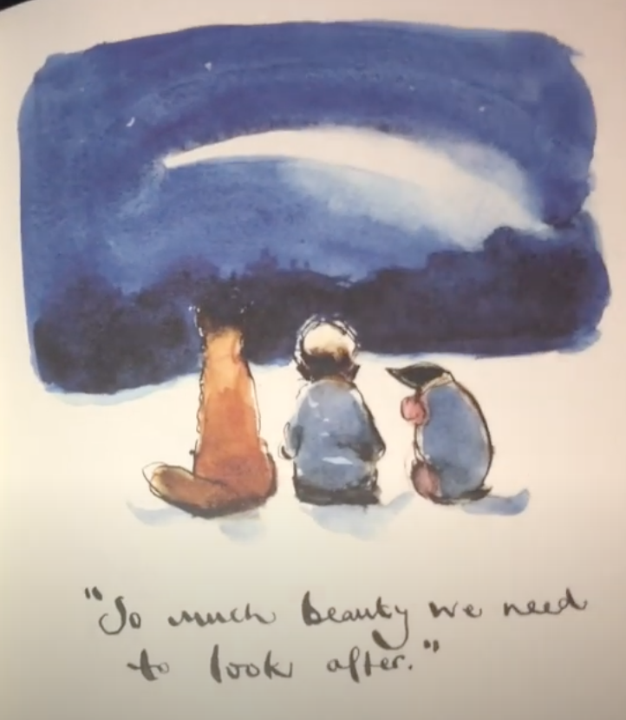
“So much beauty we need to look after.”
Use the next page to draw a picture of something beautiful you look after with the people that live with you in your home.

- Go to this page:
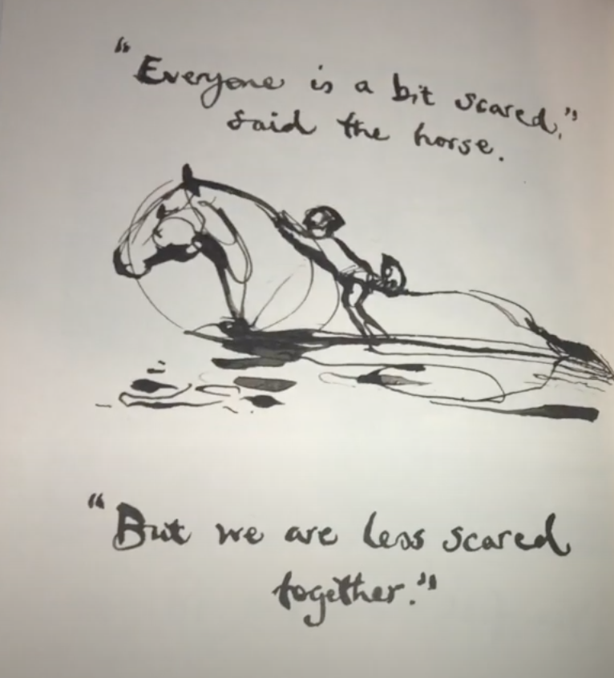
“Everyone is a bit scared, but we are less scared together.”
Describe an example of a time that you have been scared but people around you have made you feel less scared.

- Look at the picture below:
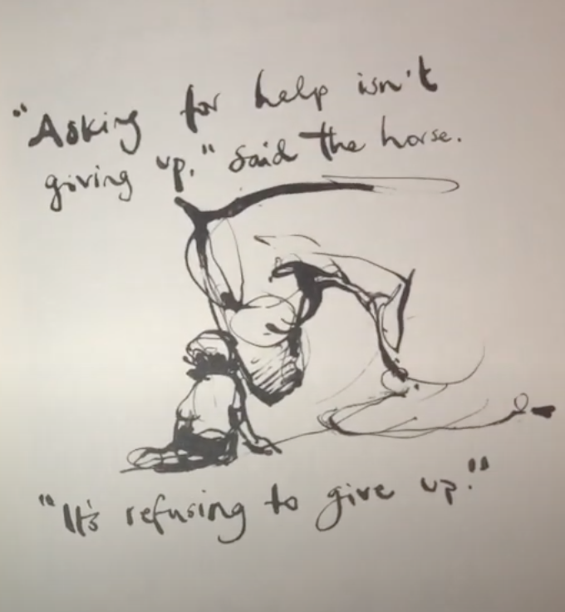

“Asking for help isn’t giving up, it’s refusing to give up.”
How do you think this message would help us at school? Can you think of any examples? Design a poster (in whatever form you want) to portray this message to help others at school when we get back?

- Stop at this page:
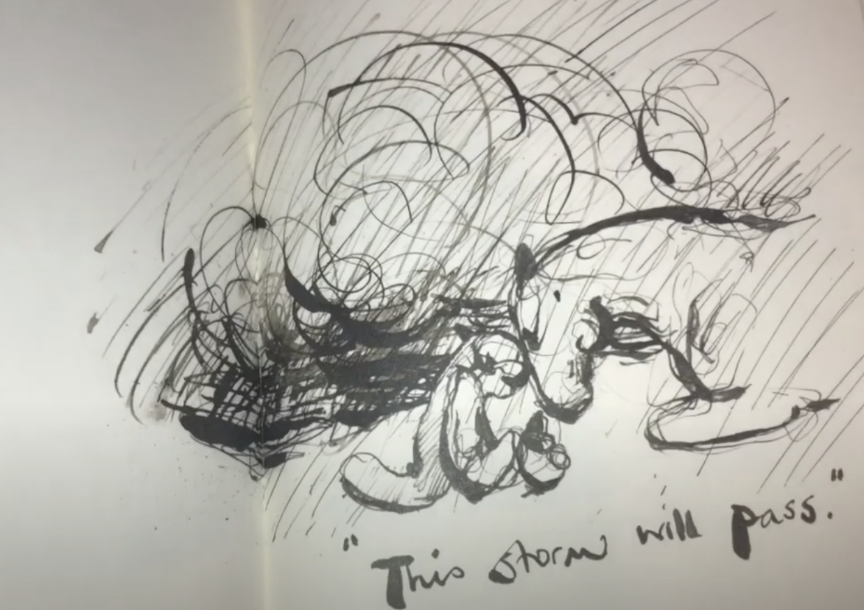

How do you think this relates to the times we are living through now?

- Stop again at this page:
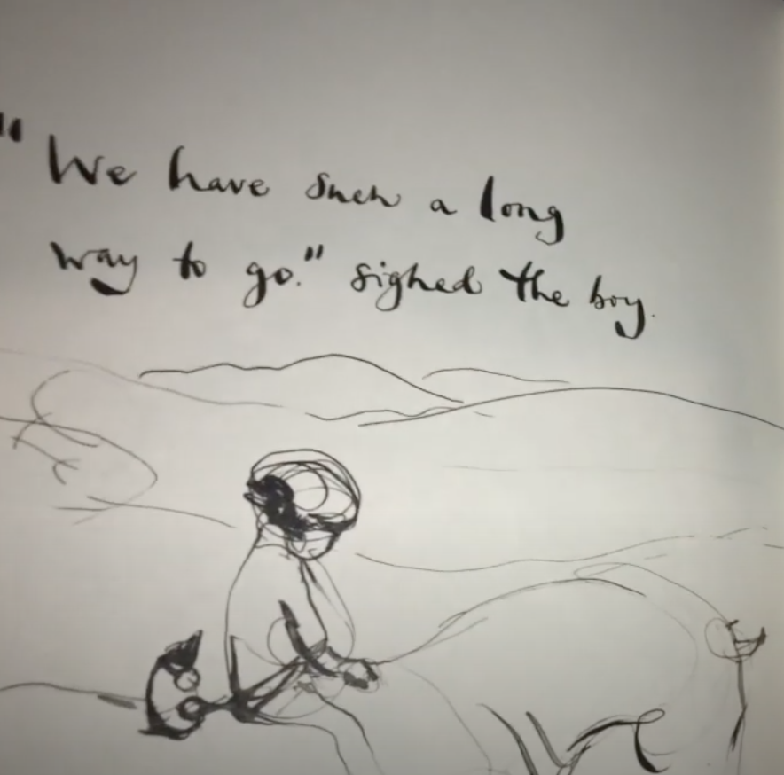

Why do you think the Author chose the verb “sighed” to describe the way the boy spoke at this point? What does it make you think about how the character is feeling?
- Who is your favourite character in the book and why? What is the most important message that your favourite character gives in the book? Draw a picture of the character here with their message:
- The Author says this about all of the characters in the book:
“They are all different, like us, and each has their own weaknesses. I can see myself in all four of them, perhaps you can too?”
Do you agree with this? Which character do you think you are most like and why?

Life cycles
