THE WITCH

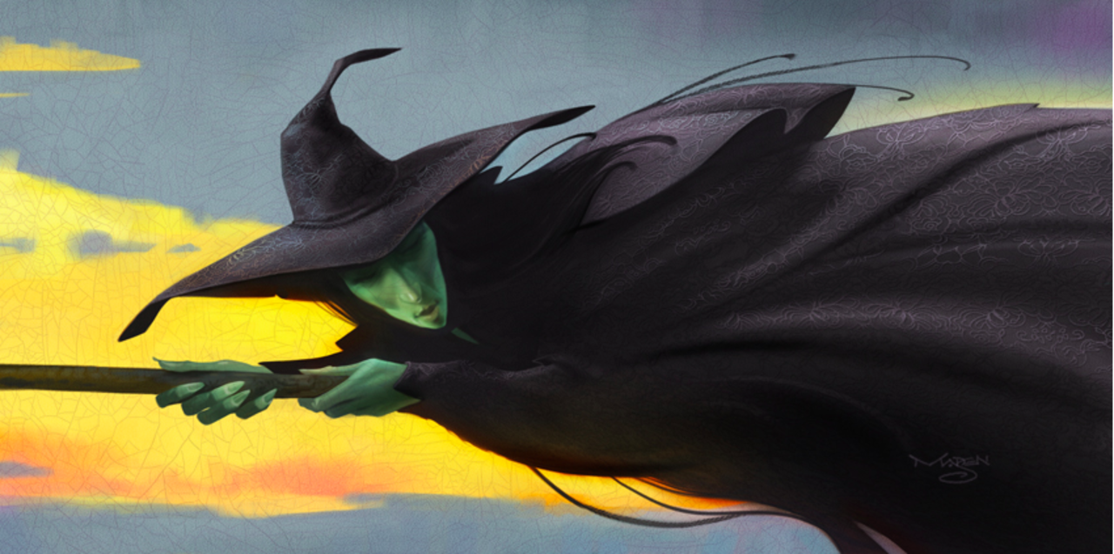

Story starter
The witch hadn’t slept for three nights. The first night she’d spent deep in thought, plotting. The second she’d spent stooped over her cauldron, muttering evil incantations as she prepared the foul and odorous brew. On the third night, the deed had been done. Without a glimmer of remorse, she took flight once again, glancing back over her shoulder at the wreckage she’d left behind. A merciless cackle escaped her chapped lips…

Question time
Where does the witch live?
What did she brew inside her cauldron?
What ingredients might she have used?
What evil deed did she carry out on the third night?
Does the witch regret what she’d done?
What powers do you think the witch possesses?

