Year 4 Learning Activities - Week Eleven 1st June 2020

Please read through the choice of activities on the next page with your grown-ups and try to complete FIVE each day. Your parents/carers can send pictures of your learning or ask any questions via my email account:
ianbeggs@st-bartholomews.brighton-hove.sch.uk
A day for the Y4 class at the moment could look like:
Time | What are we doing? | Activity choices
9.00 - 10.00 am | Active / Motivation Time | Join Joe Wicks - The Body Coach TV - youtube - for his daily workout or choose one of the activities in the pink boxes.
10.00 - 10.30 am | Reading Time | Read a book or your choice or choose an e-book on the OxfordOwls website  www.oxfordowl.co.uk/for-home/find-a-book/librar y-page
10.30 - 11.00 am | Learning Time | Play some Maths games online. Try:  coolmathgames.com or  mathsframe.co.uk
11.00 - 12.00 pm | Learning Time | Choose one of the activities from the green boxes.
12.00 - 12.30 pm | Lunch | Help to make lunch, clean up and put everything away.
12.30 - 1.00 pm | Free Play
1.00 - 2.00 pm | Creative Time | Choose one of the activities in the yellow boxes.
2.00 - 3.00 pm | Innovation Time | Choose one of the activities in the blue boxes.

Good luck and keep in touch! We look forward to seeing what you have all been up to.

Learning  Time | Creative  Time | Innovation  Time | Motivation  Time
Have a go at all of the BBC Maths lessons this week! As well as the daily Maths lessons, choose some extra ones that interest you. If you can’t decide, I’ve put arrows by ones that I recommend!  https://whiterosemaths.com/homelearning/year-4/  Maths worksheets & answers can be found on the Penguins page of the school website. __________________________  We have one of the biggest wind farms in the UK right off our coast. Why is the UK developing so much wind power? Research 5 facts here to explain why: https://www.funkidslive.com/learn/curious-kate/curious-facts-wind-power/# __________________________  Write down 6 adjectives & 2 similes to describe this room (there’s a bigger version below).  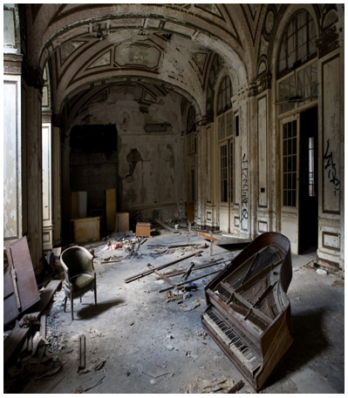  Now write a paragraph to describe walking through it!  __________________________  On each of these grids, the counters lie at the four corners of a square.  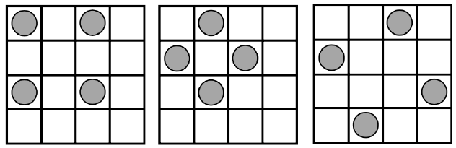  What is the greatest number of counters you can place on this grid without four of them lying at the corners of a square? | What are electrical devices and how do they get the power to work?  Look around your home and find 10 devices that get their power from a battery and 10 that get their power from a plug (the mains).  But where does the power in the plug come from? Watch this clip to find out: https://www.bbc.co.uk/teach/class-clips-video/primary-science-how-is-electricity-made/zfhfgwx  ______________________  The wind can be used to turn a machine with sails. Wind turbines, like the ones in the sea off Brighton beach, work this way. This video explains how electricity can be generated by a wind farm): https://www.youtube.com/watch?v=U5_cZ3IRUkU  ______________________  Make your own wind spinner like this:  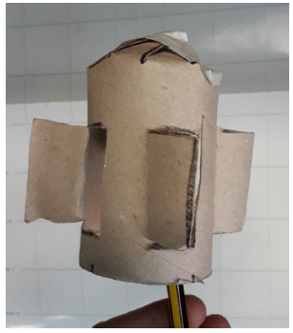  Follow the instructions below!  ______________________  Why is the wind a good way to make electricity? What other ways are there to make power? Discuss this with an adult and think of 5 ways to make power. Put them in order from the one you think is best to the one you think is worst and explain why you put them in that order. | Choose a game from ixl.com - this week, I recommend Fractions of a whole: modelling word problems:  https://uk.ixl.com/math/year-4/fractions-of-a-whole-modelling-word-problems  Easy? Explore some of the other games available on this website! Click on the words ‘Year 4’ to see all the games available.  _______________  Explore the Active Maths website: http://www.active-maths.co.uk/  Play a game on your own or with a partner - there's lots of challenges here!  _______________  Look around the house to identify the electrical dangers, using the website here: http://www.switchedonkids.org.uk/electrical-safety-in-your-home  Can you think of any others?  _______________  Explore positive and negative shapes to make great art! Watch the tutorial to see how: https://www.youtube.com/watch?v=ExeekGarOzo | We’re all allowed to take exercise outdoors, once a day, as long as we can keep a safe distance from others.  The Daily Mile at Home offers easy, fun ideas for exercise activities for you and your family: https://thedailymile.co.uk/at-home/  _______________  Teach your family how to play Shoe Bomb!  _______________  Dinosaur Spikes:  In this game, each player has a number of clothes pegs pegged to the back of their t-shirt like the spikes on the back of a dinosaur. The aim of the game is to unpeg as many of your opponents’ pegs as possible. When a player manages to take a spike from someone’s back, they can peg it on to the front of their t-shirt. Pegs cannot be stolen from people’s fronts. When the game ends, whoever has the most spikes is the winner!  _______________  Follow an online yoga video at Cosmic Kids  cosmickids.com

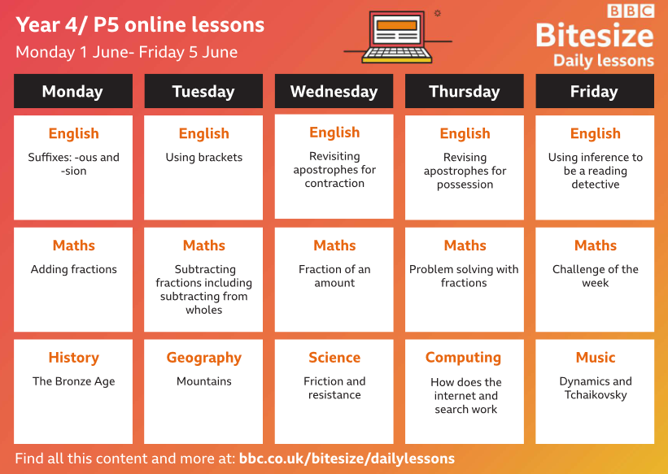

Descriptive writing
Look carefully at the floor, the ceiling, the walls, doors, windows and individual objects for ideas.

Making a wind spinner
You will need: a card tube, a felt pen, scissors
- First, mark the tube into quarters.
- Next, draw a flap to cut out on each quarter, near the bottom of the tube (you’ll need space at the top later). Make sure that each flap will open on the left.
- Cut out the flaps along three of their sides and press them outwards, being careful not to tear the card in between. If it’s tricky to do this with scissors, you might want to ask an adult to help you use a craft knife, being very careful about safety!
- Next, cut roughly 9 equally spaced slits into the end of the toilet roll tube and fold them in to meet each other, forming a nose cone. Secure the cone at the end with tape.
- Finally, balance the spinner on a pen or pencil and blow to make it spin.

