A day for the Y6 class at the moment could look like:
Time | What are we doing? | Activity choices
9.00-10.00am | Active / Motivate Time | Join Joe Wicks – The Body Coach TV – you tube –for his daily workout or choose one of the activities in the blue boxes.
10.00-10.30am | Reading Time | Read a Collins e-book https://collins.co.uk/pages/support-learning-at-home or choose one of the activities in the orange boxes.
11.00-12.00pm | Learning Time | Choose one of the activities in the green boxes.
12.00-12.30pm | Lunch | Help make lunch, set the table and put everything away.
12.30-1.00pm | Free Play | Have a rest and play with some toys or relax.
1.00-2.00pm | Creative Time | Choose one of the activities in the yellow boxes.
2.00-3.00pm | Learning Time | Choose one of the activities in the green boxes.

Jaguars Learning Activities – Week 5
Please read through the choice of activities with your grown-ups. Your parents / carers can send pictures of your learning or ask any questions via my email account: fionakeeling@st-bartholomews.brighton-hove.sch.uk
Click on the blue writing to go straight to the website.
Learning Time | Creative Time |  | Active / Motivate Time | Reading Time
The Boy in the Striped Pyjamas  Chapter 10 – The Dot That Became a Speck That Became a Blob That Became a Figure That Became a Boy – pages 57-62  In Chapter 10, Bruno wants to ask Shmuel why he looks so sad.  Write what Shmuel would have said to Bruno if he was telling the truth.  Daily Maths Lesson  Complete a daily maths lesson from  White rose.  or  iseemaths |  | 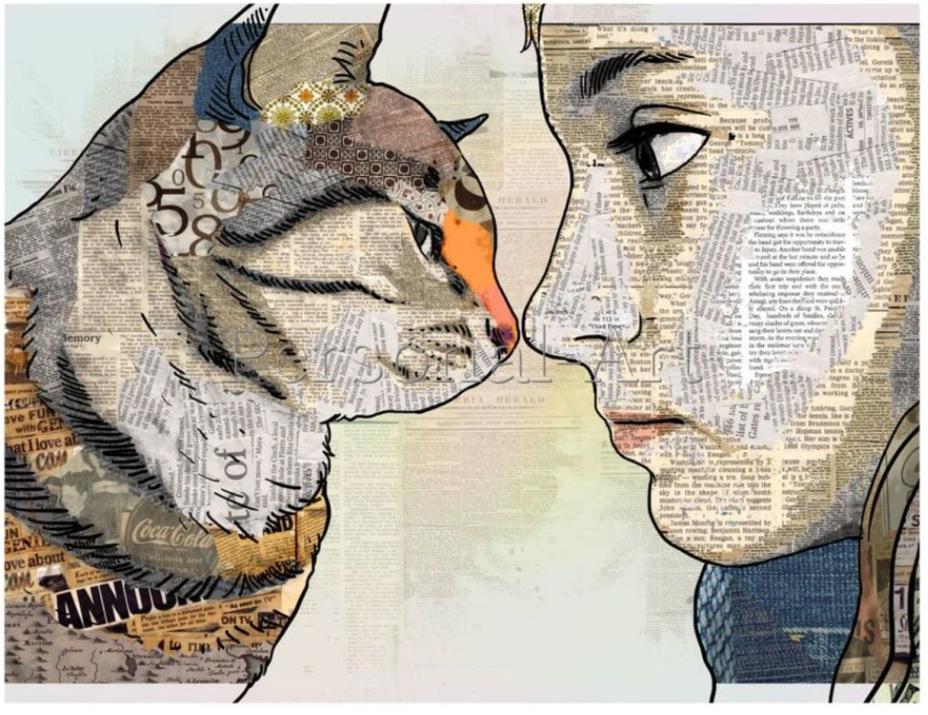 | Relative Clauses–  Super movers  Try this great work out of your body and brain.  Juggling with Socks  Teach yourself to juggle using 3 pairs of socks. | The Boy in the Striped Pyjamas  Have you read the book now?  Re-read chapter 10 – The Dot That Became a Speck That Became a Blob That Became a Figure That Became a Boy – pages 57-62 or listen to it here.  Think about the similarities and differences between Bruno and Shmuel.  Strange Reading Photos  Can you take some photographs of you reading in strange places on lockdown? Send them to me and Star will vote the winner!

Learning Time | Creative Time | Active / Motivate Time | Reading Time
A Day in the Life of a Spoon  I would like you to write about a day in the life of a spoon from the spoon’s point of view. Start your piece of writing from when you woke up, e.g.  Today I awoke to the deafening shrill of the giggling knives in the bed next to me.  Penguin Cam  Watch the penguin cam from Edinburgh Zoo. Imagine that some of the penguins are having a conversation. What are they saying?  Story Starter  Finish the story…  - Footsteps slowly creaked on every step of the stairs. The bedroom door handle turned slowly. | Collage Time  Have a look at the image above.  Draw an outline of your profile – and the profile - an outline of something, especially a person's face, as seen from one side- of your pet or an animal you love. Then use magazines or even an old book to collage the images. Add some detail in with a black pen.  If you don’t have any glue, then you could just use pen to add detail.  I can’t wait to see these!  Cooking Time  I have seen the most amazing pictures of the meals that you have been making. Let’s have another dinner this week.  Drawing Spirals  Follow the video to see how to draw spiral art – it’s really good for feeling calm and relaxing!  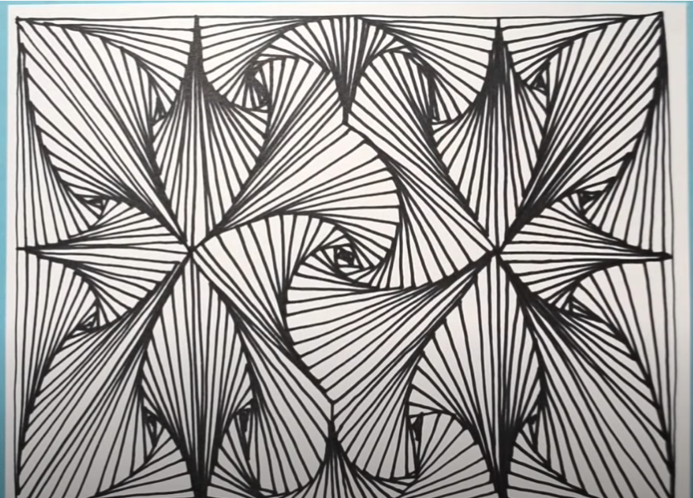 | PE with Joe  I am doing this every morning and it’s fun, but my legs hurt!  PE with YOU  Create your own 10-minute workout in the style of Joe Wicks. Test it out on the people at home.  Just Dance  Get everyone in your house joining in with your favourite just dance song! | Beetle Queen  Read the extract from ‘Beetle Queen’.  What does the last line of the extract - ‘Actually, it’s made of beetles.’  have to do with the quote -  “We can judge the heart of a man by his treatment of animals.”  by the German philosopher Immanuel Kant?  A Miscellany of Magical Beasts  Read the extract from ‘A Miscellany of Magical Beasts’ by Simon Holland.  If you were to write a guide for a magical beast, what would it be?

