Year 3 Learning Activities - Week Nine 18th May 2020
Please read through the choice of activities on the next page with your grown-ups and try to complete a few each day. Your parents/carers can send pictures of your learning or ask any questions via my email account:
helenbanks@st-bartholomews.brighton-hove.sch.uk
A day for the Y3 class at the moment could look like:
Time | What are we doing? | Activity choices
9.00 - 10.00 am | Active / Motivation Time | Join Joe Wicks - The Body Coach TV - youtube - for his daily workout or choose one of the activities in the pink boxes.
10.00 - 10.30 am | Reading Time | Read a book or your choice or choose an e-book on the OxfordOwls website  www.oxfordowl.co.uk/for-home/find-a-book/library-page
10.30 - 11.00 am | Learning Time | Play some Maths games online. Try:  coolmathgames.com  or  mathsframe.co.uk
11.00 - 12.00 pm | Learning Time | Choose one of the activities from the green boxes.
12.00 - 12.30 pm | Lunch | Help to make lunch, clean up and put everything away.
12.30 - 1.00 pm | Free Play
1.00 - 2.00 pm | Creative Time | Choose one of the activities in the yellow boxes.
2.00 - 3.00 pm | Innovation Time | Choose one of the activities in the blue boxes.

Good luck and keep in touch! We look forward to seeing what you have all been up to.
Learning  Time | Creative  Time | Innovation  Time | Motivation Time
BBC Bitesize are offering 3 daily lessons every day - online or on the BBC iPlayer. Have a look at this week's schedule and choose at least 3 activities that interest you.  ____________________________  This week's Maths videos are here:  https://whiterosemaths.com/homelearning/year-3/  The worksheets are available on our Year 3 class page of the school website.  We covered quite a lot of this before school changed, but it will be useful revision and get you thinking all about fractions again!  ___________________________________  Superhero story writers needed! Take part in Medical Detection Dog’s Superhero Story Writing Competition!  https://www.medicaldetectiondogs.org.uk/superhero/  They believe superheroes come in all different sizes and particularly with four legs, a waggy tail and an incredibly  special nose!  Use the story writing resources to help you write a story about your superhero. Entries must be a maximum of 800 words and the competition closes on Friday 29th May at 20:00. If you want to write a story, but not enter the competition, just email me and I will enjoy reading it!  ____________________________  Have a go at Nrich’s maths counting challenge https://nrich.maths.org/14404. Click on Getting Started if you get stuck or need a few ideas. There are also possible solutions as well so you can see how others have solved it! | Sophia Barnacle was a British inventor who, in 1907, invented the Helterskelter. Try using junk box material to make your own structure such as a helter-skelter or marble run.  To find out more about designing and building your own structure, click here https://www.jamesdysonfoundation.co.uk/resources/challenge-cards.html and scroll down to Challenge 03, Marble Run activity.  ______________________  Use an old magazine to create a mood board. Cut out your favourite images, colours and sentences to create a collection of glued down images which reflects your personality, favourite things and emotions.  ______________________  Make a dream catcher using an old cd or anything circular and some string, beads and ribbon (see examples on next page).  ______________________  Redesign and draw an alternative book cover for one of your favourite books.  Think about the colours and images that you could use.  _______________________  Stick some string on a piece of card and paint over it or inside the shapes that you make  (see examples on next page). You could make a rainbow! | Spellings:  Practise your split vowel digraphs.  a-e e-e i-e o-e u-e  Practise these spellings using different methods such as ‘pyramid’, ‘rainbow writing’, ‘box it in’ and ‘draw the word’. If you’ve forgotten what a split digraph is, watch this video https://www.youtube.com/watch?v=L7faYbILI1s.  After, write down a list of all the split digraph words you can think of.  Here are some examples:  Flame Athlete Prize  Alone Computer Arrive  Complete Decide Describe  _____________________  The Royal Horticultural Society (RHS) is the UK’s leading gardening charity. They aim to enrich everyone’s life through plants, and make the UK a greener and more beautiful place. Click here  https://www.rhs.org.uk/gardens to explore the RHS website: take a virtual tour of the RHS Gardens to see what their gardens look like, or get involved in one of their monthly activities.  _____________________  The UK is full of lots of different kinds of trees. All are beautiful and unique in their own way. Identifying a tree isn’t as hard as it seems… Click here  https://www.bbc.co.uk/newsround/52545218  to test your knowledge and see if you can identify the different types of trees. Next time you're outdoors, use your tree knowledge to identify the trees that you see! | As a family, discuss the famous people that may have had an impact on your lives and the choices your adults have made about the jobs they have chosen.  Talk about who has inspired them and why. You can create a family picture that illustrates inspirations and choices.  _____________  Ask your parents and other family members what games and activities they used to enjoy before iPads and computers were so widely used. Give some of them a go instead of playing a game on your console or tablet.  _____________  Get comfy and read a book on Epic!  https://www.getepic.com/

Helter Skelter

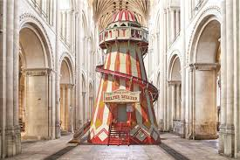Marble Run in a box
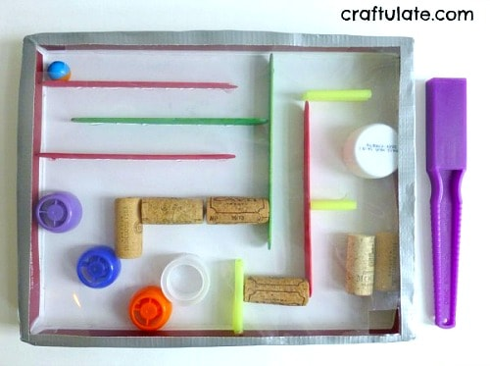

String paintings

Homemade Dreamcatcher

