A day for the Y5 class at the moment could look like:
Time | What are we doing? | Activity choices
9.00-10.00am | Active / Motivate Time | Join Joe Wicks – The Body Coach TV – you tube –for his daily workout or choose one of the activities in the blue boxes.
10.00-10.30am | Reading Time | Read a Collins e-book https://collins.co.uk/pages/support-learning-at-home or choose one of the activities in the orange boxes.
11.00-12.00pm | Learning Time | Choose one of the activities in the green boxes.
12.00-12.30pm | Lunch | Help make lunch, set the table and put everything away.
12.30-1.00pm | Free Play | Have a rest and play with some toys or relax.
1.00-2.00pm | Creative Time | Choose one of the activities in the yellow boxes.
2.00-3.00pm | Learning Time | Choose one of the activities in the green boxes.

Learning Time | Creative Time | Active/Motivate time | Reading time
BBC BITESIZE : https://www.bbc.co.uk/bitesize/dailylessons

SUPER SENTENCE STACKERS  9:45am  LIVE WRITING LESSONS!  www.youtube.com/c/thetrainingspace  These are so good.  THE GIRL AND THE LITTLE RED BALLOON (BANKSY)  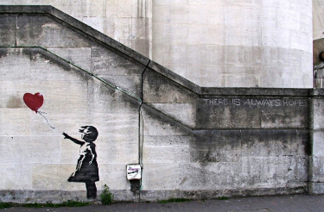  I have put the picture with a story starter under the grid.  Can you tell the story of the little girl and the red balloon?  MATHS LESSON with  WHITE ROSE or BBC BITESIZE  I am putting the White Rose lessons on the class page each week. If you want to watch the video to support the learning, you will find it on the White Rose website link:  www.whiterosemaths.com/homelearning/year-5/  The focus this week is on ADDING AND SUBTRACTING FRACTIONS AND MIXED NUMBERS  Watching the video may help to understand the methods used to answer the questions. Fractions is a big part of the Year 5/6 curriculum, so it’s good to try to be confident with them.  MS SOAR’S MATH’S CHALLENGES:  A bit fishy  A goldfish costs £1.80.  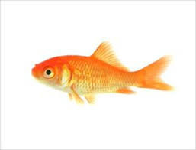  An angel fish costs £1.40.  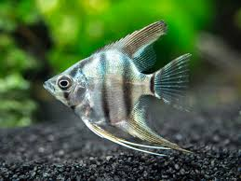  Nasreen paid exactly £20 for some fish.  How many of each kind did she buy? | ORIGAMI PAPER HEARTS  A little bit of origami this week! Paper hearts! All you need is a square of paper, decorate it however you like. You can pop messages inside, string them up to make a garland, pop them in the post or keep them for yourself!  https://www.youtube.com/watch?v=kfgZj3aYX6M  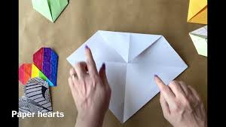  CAN YOU BUILD YOUR OWN CARD TOWER?  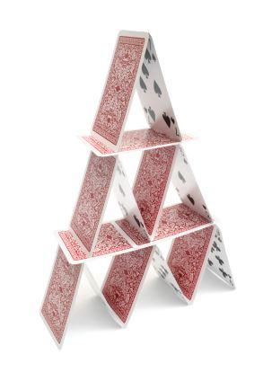  Grab a pack of cards if you have some. Can you build a tower? How easy is it? Send me photos of your towers before they fall down!  PANGOLIN MAGIC  Can you learn or practise a magic trick? If you can do one, video it so we can share with the rest of your classmates on the class page!  DESIGN YOUR OWN CHOCOLATE BAR!  Sketch the product. What does the wrapper look like? What type of chocolate is it? What is its name? Can you think of a tagline to go with your product? Look at some chocolate bars for inspiration. Why should people buy your chocolate bar?  Tagline examples:  The lighter way to enjoy chocolate (Maltesers)  Feel the bubbles (Aero)  The taste of paradise (Bounty)  Why have cotton when you can have silk? (Galaxy) | SUSSEX SCHOOL GAMES  This is a fun way to keep active. Can you improve on your score each week?  www.sussexschoolgames.co.uk  DAILY WALK – RAINBOW PHOTO CHALLENGE  Can you use a phone or an old camera to take photos of objects that make up the colours of the rainbow? I think Indigo and violet might definitely be the hardest to find, but look all around you at nature and man-made things. If you want to email your rainbow pictures, I’d love to see them!  CIRCUIT TRAINING  Can you create a circuit of exercises either in your house, garden or safely in a public place? It might include: star jumps, step ups, hula hooping, sit ups. Whatever you fancy really! There just needs to be a start and an end. Can you race against your family? Can you improve on your time? Let me know how you get on!  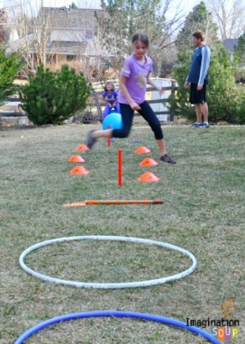 | ‘JUST A BOOK’ – by JOSHUA SEIGAL  Read the poem that I’ve put under this grid then choose one of these activities to do:  *Write a paragraph or two explaining what you think the poem means.  * Write a review of the poem. Why you did or didn’t like reading it.  *Create a piece of artwork based around the poem.  *Create a list of effective words used in the poem and explain why.  *Write your own poem in the same style or about the same topic.  *Write a piece of NARRATIVE writing that links to the poem.  *Explain how this poem makes you feel and why.  *Write a list of questions you have about the poem  READ FOR 20 MINUTES EVERY DAY  If you are struggling to find something to read, please email me.  PANGOLIN READING CHALLENGE  Do I need to add any finished books to our Pangolin bookshelf? Let me know!  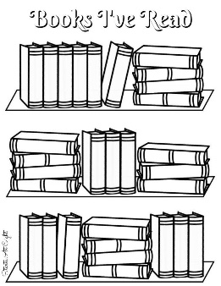  THE BOY, THE MOLE, THE FOX AND THE HORSE  Have a look at the resources I put up last week if you didn’t have a chance to. There are some lovely ideas.  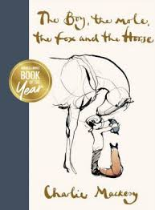

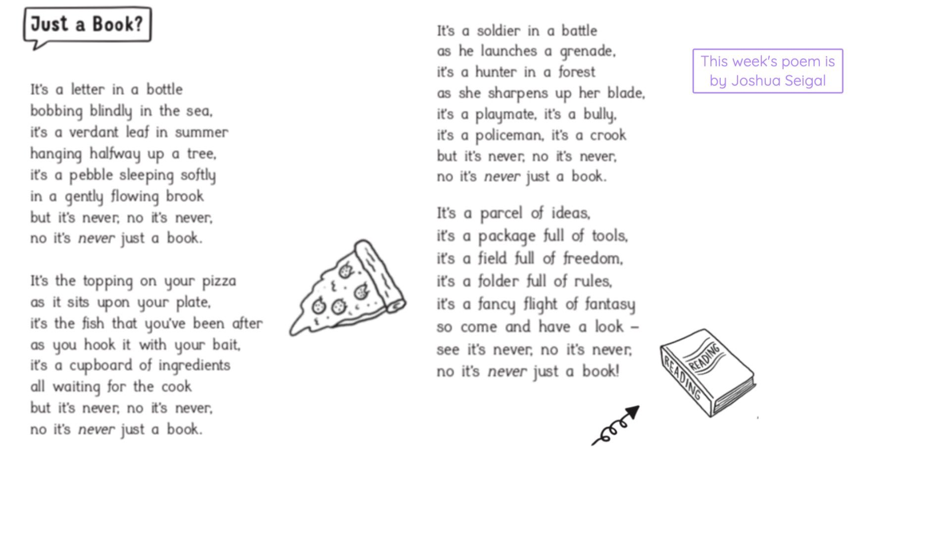

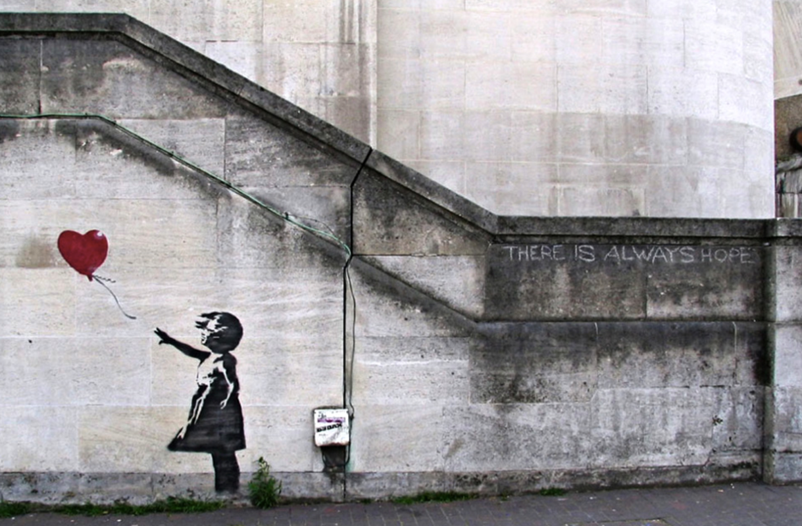

Story starter
In a world where everything seemed black and white, it brought colour. In a world where things were often bleak, it brought joy.
The drawing of a girl’s outstretched fingers pointed at the red balloon as it floated skywards.
Many years ago a real girl had held a real balloon, releasing it into the sky as she hoped her dreams and prayers would be answered. Now, her image and memory were etched on the very walls behind the spot where she once stood.
Her story, and that of the red balloon, would be told for many generations to come…
Can you tell the story of the little girl and the red balloon?

