A day for the Y5 class at the moment could look like:
Time | What are we doing? | Activity choices
9.00-10.00am | Active / Motivate Time | Join Joe Wicks – The Body Coach TV – you tube –for his daily workout or choose one of the activities in the blue boxes.
10.00-10.30am | Reading Time | Read a Collins e-book https://collins.co.uk/pages/support-learning-at-home or choose one of the activities in the orange boxes.
11.00-12.00pm | Learning Time | Choose one of the activities in the green boxes.
12.00-12.30pm | Lunch | Help make lunch, set the table and put everything away.
12.30-1.00pm | Free Play | Have a rest and play with some toys or relax.
1.00-2.00pm | Creative Time | Choose one of the activities in the yellow boxes.
2.00-3.00pm | Learning Time | Choose one of the activities in the green boxes.

Learning Time | Creative Time | Active/Motivate time | Reading time
Check out what BBC Bitesize have produced. There are daily English and Maths lessons as well as other subjects that might be a lot of fun. Just click on the year 5 daily lessons.
https://www.bbc.co.uk/bitesize/dailylessons

SUPER SENTENCE STACKERS  LIVE WRITING LESSONS!  Become a ‘Super Sentence Stacker’! Learn from the master!  Log in each day at 9:45am. One of these lessons a week will definitely sharpen your writing skills. I can’t recommend this enough. IT IS AMAZING (in my opinion!)  Subscribe to the You tube channel  www.youtube.com/c/thetrainingspace  Email me any of your writing pieces.  SENTENCE OPENER  It began on a Friday, as strange things often do. This particular Friday turned out to be stranger than most.  This is the opening sentence from ‘Who let the Gods out.’ I would like you to have a go at completing the story. Remember: fabulous vocab, accurate punctuation and different sentence types. Can you put a simile in? Go for it! Let your imaginations go WILD!  MATHS LESSON with  WHITE ROSE  This week it is all +/- decimals, so it will be invaluable. I think the video you watch before answering the questions really helps too. Look out for the challenge on Friday and send any in to me.  www.whiterosemaths.com/homelearning/year-5/  MS SOAR’S MATH’S CHALLENGE:  1, 2, 3, 4  Using the digits 1, 2, 3 and 4 and +, - , x and ÷ symbols make the numbers from 1 to 30.  Each of the numbers has to be used every time, for example 1 + 2 + 3 + 4 = 10. | GREEK GOD OR GODDESS RESEARCH  Create a fact file poster of a Greek God or Goddess of your choice. Draw a picture of them and then add facts such as:  NAME:  GOD OF:  SYMBOL:  FESTIVALS:  INTERESTING FACTS and DISTINGUISHING FEATURES:  Look at the file I have attached with some images of the Greek Gods and Goddesses (that are actually fully dressed for a change!)  HAVE A GO AT MAKING YOUR OWN INSTRUMENTS!  Whether it’s a drum, or a tin can maraca, why not have a go at making an instrument? Perhaps you can have a jam with your family! The website below has some great ideas.  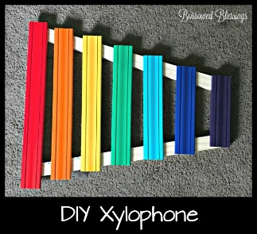  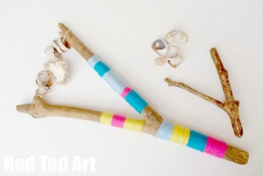  www.artsycraftsymom.com/diy-musical-instruments-for-kids-to-make-and-play/  FOUR SEASONS IN ONE PICTURE  Have a go at creating a ‘four seasons in one ????’ picture. You will need just one page, split into quarters, and one image that stretches throughout. It would help if it was something wide!  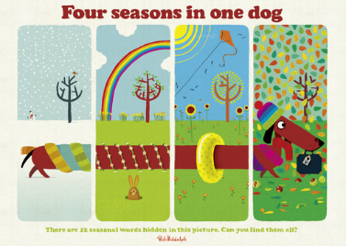  I have put a bigger version of the Rob Biddulph illustration under the learning grid. | GO NOODLE  There are lots of songs here to sing and dance to!  YOGA  Follow an online yoga video with Cosmic Kids.  LEARN A DANCE ROUTINE WITH  OTI MABUSE – 11:30am daily.  DAILY WALK  On your daily walk with a grown up, remember to be careful with social distancing,  write a letter for one of your friends who lives nearby. Post it through the letterbox when you walk past their house. If you write several in your family you could plan your route first.  STICK TOWER CHALLENGE  Go outside and find some sticks and take part in a stick tower challenge. You can use whatever you have at home to bind the sticks together – string, tape, ribbons, plasticine or anything else you can find. Split into two family teams and see who can build the tallest or work together to make one that is taller than the tallest person in your house!  PHOTOS PLEASE! | WHO LET THE GODS OUT? BY  MAZ EVANS  Let me know if you read the first chapter! Did anyone manage to download it? I know at least one Pangolin has borrowed the book from the online library service. Well done!  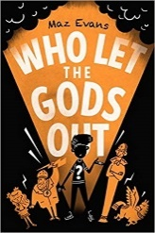  AUDIBLE version is free.  The library’s BORROWBOX service is free.  KINDLE DOWNLOAD is 99p.  THE BOOK OF HOPES  This is a wonderful collaboration of authors and can be downloaded for FREE on the website shown below the grid. It has been written for children as a bit of support during this time. It will definitely be good to dip in and out of.  READ FOR 20 MINUTES EVERY DAY  If you are struggling to find something to read, please email me.  SHOW ME WHAT YOU’RE READING!  Send me a photo of what you are reading! Whether it is a comic, graphic novel, fiction or non-fiction book, I’d really like to know.  PANGOLIN READING CHALLENGE  When you’ve finished reading a book, email me to let me know what it’s title, and we will see if we can reach a class total of 30 books. I would like to fill this bookshelf with your completed reads:  That would be so brilliant! This bookshelf will be filled in as I get your finished reads, and we will be able to map our class progress!

