A day for the Y5 class at the moment could look like:
Time | What are we doing? | Activity choices
9.00-10.00am | Active / Motivate Time | Join Joe Wicks – The Body Coach TV – you tube –for his daily workout or choose one of the activities in the blue boxes.
10.00-10.30am | Reading Time | Read a Collins e-book https://collins.co.uk/pages/support-learning-at-home or choose one of the activities in the orange boxes.
11.00-12.00pm | Learning Time | Choose one of the activities in the green boxes.
12.00-12.30pm | Lunch | Help make lunch, set the table and put everything away.
12.30-1.00pm | Free Play | Have a rest and play with some toys or relax.
1.00-2.00pm | Creative Time | Choose one of the activities in the yellow boxes.
2.00-3.00pm | Learning Time | Choose one of the activities in the green boxes.

Learning Time | Creative Time | Active/Motivate time | Reading time
Check out what BBC Bitesize have produced. There are daily English and Maths lessons as well as other subjects that might be a lot of fun. Just click on the year 5 daily lessons.
https://www.bbc.co.uk/bitesize/dailylessons
This may be the way to go for Math’s lessons and other lessons if you have access to the Internet.
SUPER SENTENCE STACKERS  9:45am  LIVE WRITING LESSONS!  www.youtube.com/c/thetrainingspace  Email me any of your writing pieces.  SENSES WALK WRITING  After one of your daily walks this week, where you will have built up some language for each of the 5 senses, have a go at writing a poem about Walking during Lockdown. I’ve certainly noticed some differences on my daily walks.  DIARY  If you haven’t started one already, grab a notebook and do some reflective writing about how you are feeling and what sort of things you have been getting up to.  MATHS LESSON with  WHITE ROSE  They seem to be pairing up with BBC bitesize from Monday, so if you can’t find your White Rose lesson, go to the BBC page instead.  www.whiterosemaths.com/homelearning/year-5/  MS SOAR’S MATH’S CHALLENGES:  Creepy Crawlies  Mr Mills collects lizards, beetles and worms. He has more worms than lizards and beetles together. Altogether in the collection there are twelve heads and twenty-six legs. How many lizards does he have?  Pentominoes  Have a go at cutting out the shapes. Can you arrange them to fit into the bigger shapes? This will flex your brain muscles! It is below the grid. | MA MAISON FANTASTIQUE  (MY AMAZING HOME)  A chance to practise and learn some new French vocabulary.  Draw a picture of your dream house. You can have anything you want! A balcony, a pool, a games room! Use a dictionary to find the names for some of the things you’ll have in your home and label the picture neatly. If you don’t have a French dictionary at home, go to:  www.collinsdictionary.com/dictionary/english-french  DRAWING WITH EVERYDAY OBJECTS  Look at the sheet below the grid. It shows some wonderful examples of using everyday objects, such as scissors or fruit to make some great pictures. Have a go and then email me your creations!  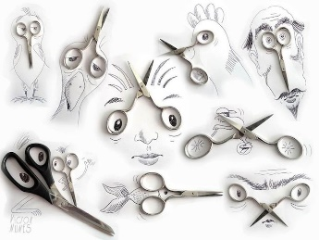  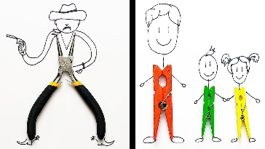  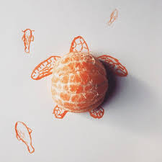  I can’t wait to see what you get up to!  BECOME A COMPOSER!  BBC TEN PIECES  Get creative with body percussion and storytelling, using Steve Reich's Music for 18 Musicians as inspiration.  Get your hands, feet and imaginations ready to compose your own piece of minimalism!  https://www.bbc.co.uk/teach/ten-pieces/watch-this-do-this-weekly-activities/zjy3382 | SUSSEX SCHOOL GAMES  www.sussexschoolgames.co.uk  Mr Mills sent out a PING message at the end of last week, letting you know about this. All schools in Sussex are signed up, and it is really easy to log your scores. Last week, involved 4 hockey skills and it’s just a bit of active fun really. Really straightforward and accessible for all if you can get to the website.  GO NOODLE  YOGA - Cosmic Kids.  LEARN A DANCE ROUTINE WITH  OTI MABUSE – 11:30am  DAILY WALK  Take some paper or a notebook and on your daily walk. Have a go at writing about things that you:  *see  *hear  *feel  *smell  *taste  as you walk around. Try to describe things in the most creative way. | WHO LET THE GODS OUT? BY  MAZ EVANS  Did you enjoy the first chapter? Who has managed to read any more of it? It is VERY funny.  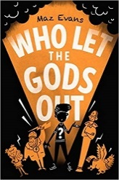  AUDIBLE version is free.  The library’s BORROWBOX service is free.  KINDLE DOWNLOAD is 99p.  PERSEUS AND MEDUSA  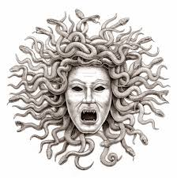  Read this Greek myth. It is only short and is on the Pangolin learning class page. Then choose to:  *create a story map, summarising the order of events.  *Turn the story into a comic.  *Draw a picture of one of the main characters and make notes around it, telling me about the character traits.  READ FOR 20 MINUTES EVERY DAY  If you are struggling to find something to read, please email me.  BUILD YOUR OWN READING DEN!  I would like you to create a reading den, a cosy little space, somewhere where you know you won’t get disturbed. Then send me a photo of you reading here. I’d love to see these!  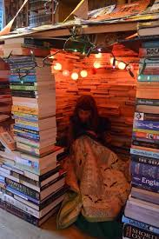  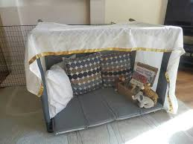  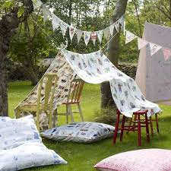  PANGOLIN READING CHALLENGE  We can do this!  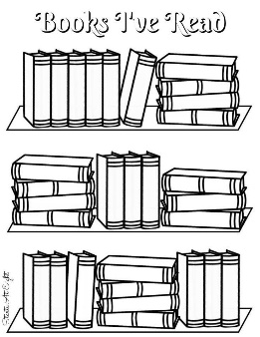  Remember, we are going to try to fill these bookshelves. I know one Pangolin is nearing the end of a book!  Let me know how you are doing and then I can update the shelf!

