A day for the Y6 class at the moment could look like:
Time | What are we doing? | Activity choices
9.00-10.00am | Active / Motivate Time | Join Joe Wicks – The Body Coach TV – you tube –for his daily workout or choose one of the activities in the blue boxes.
10.00-10.30am | Reading Time | Read a Collins e-book https://collins.co.uk/pages/support-learning-at-home or choose one of the activities in the orange boxes.
11.00-12.00pm | Learning Time | Choose one of the activities in the green boxes.
12.00-12.30pm | Lunch | Help make lunch, set the table and put everything away.
12.30-1.00pm | Free Play | Have a rest and play with some toys or relax.
1.00-2.00pm | Creative Time | Choose one of the activities in the yellow boxes.
2.00-3.00pm | Learning Time | Choose one of the activities in the green boxes.

Jaguars Learning Activities – Week 3
Please read through the choice of activities with your grown-ups. Your parents / carers can send pictures of your learning or ask any questions via my email account: fionakeeling@st-bartholomews.brighton-hove.sch.uk
Learning Time | Creative Time |  | Active / Motivate Time | Reading Time
Adventure Story  Read the story opener on the website. Your task is to finish the story. Don’t forget to think about what a poggle is?  Animal Superhero  Create a report using the animal superhero sheet on the website about your favourite animal. |  | What is a Poggle?  Miss Keeling would like an illustration of a poggle for your adventure story.  Cooking Time  With the help of an adult, can you create a new recipe and cook something for Easter out of the resources you have. Remember not to waste anything! | PE with Joe  I am doing this every morning and it’s fun, but my legs hurt!  Go Noodle – Try Strengthen your focus  https://family.gonoodle.com/  Yoga  Follow an online yoga video with Cosmic Kids. | Read a favourite book  Write a book review. If it was a fiction: -Draw your favourite scene -Draw and describe your favourite character If it was non-fiction -Detail 5 key facts in your own words and explain their importance.  The Boy in the Striped Pyjamas  Last week, I put the whole book on the website. After reading the rest of the book, I’d like you to create a poster of the events in the story.

Learning Time | Creative Time | Active / Motivate Time | Reading Time
Daily Maths Lesson  Complete a daily maths lesson from  White rose.  or  iseemaths  Science - Natural History Museum  Go on a virtual tour of the Natural History Museum in London - Choose some artefacts that you find interesting and find out more about them.  You could film yourself giving more information in the style of David Attenborough.  Role-play with your family  Imagine you are a famous climate change activist.  You need to convince them of the things they need to do to improve the world so that the future generations still have a wonderful planet and animals to enjoy.  You will need some posters and a presentation to help them understand your message.  Design something new  Use a piece of fabric that you have home e.g. a sock, an old pillowcase, an old tea towel. You will then need to make it using your sewing skills. You can add as many or as few extra details as you would like. Your new item must fulfil this design brief. It must be:  - Used for storage  - Can carry at least one item | When I grow Up  Look at this image. It is taken from a book called ‘The Boy, the mole, the fox and the Horse’ by Charlie Mackery.  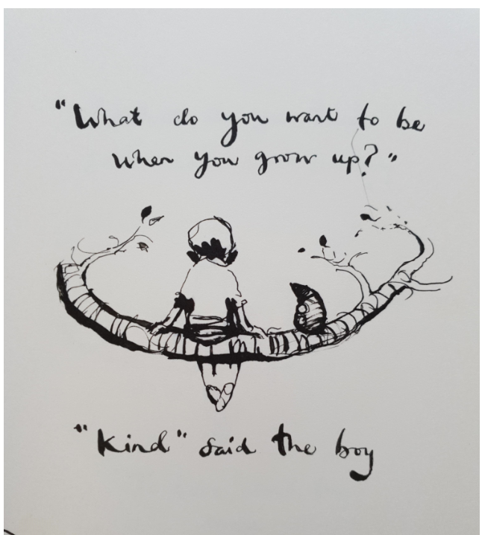  Imagine that you are sitting on a branch with an animal. What do you want to be when you grow up?  Create an illustration like this one thinking about what you want to be.  Draw with Rob Biddulph  http://www.robbiddulph.com/draw-with-rob  Learn to draw like a professional illustrator – this is great fun and of course there is a sausage dog in one of them! | PE with YOU  Create your own 10-minute workout in the style of Joe Wicks. Test it out on the people at home. | The 1000-Year-old Boy  Many of you read ‘Time Travelling with a Hamster’ in class. This is the new book by Ross Welford. Read the extract that I have put on the website and tell me why you would or wouldn’t want to read more?

