A joke from Star xx

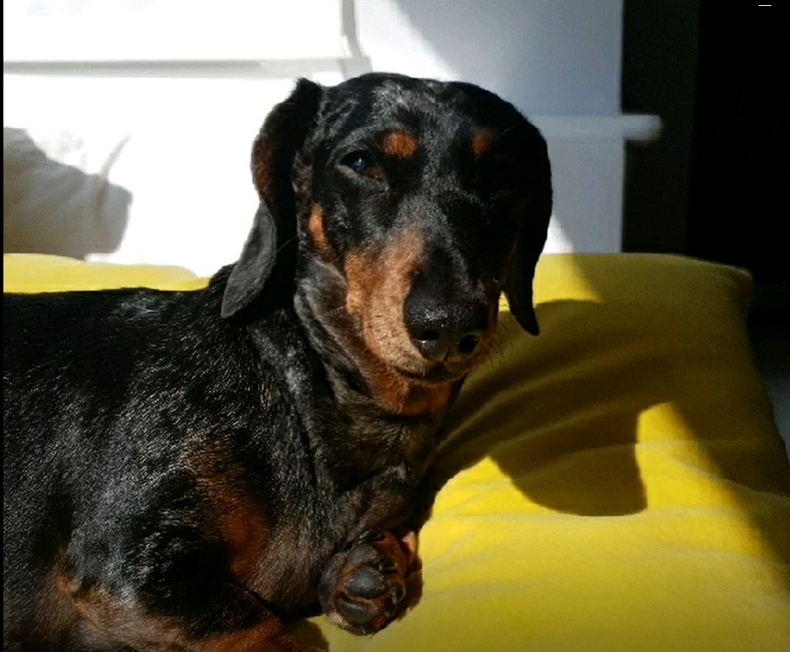

|  |  |  |  |
| --- | --- | --- | --- |
| Click on the **blue writing** to go straight to the website. | |  |  |
| Learning Time | Creative Time | Active / Motivate Time | Reading Time |
| **Chaperon Rouge**  We are going to create a piece of writing that is mysterious and filled with tension, based on Little Red Riding Hood.  Watch the film [**Chaperon Rouge here**](https://www.youtube.com/watch?v=XyTDRzV9IcM)**.**  **How do you think as she looks around the derelict city?**  **How could we show her apprehension and thought?**  **What caused the destruction?**  **Was it like this the last time she visited Grandmother’s house?** | **Banksy Superhero Art**  Banksy has produced a new piece of art showing a boy playing with a toy nurse dressed as a superhero. I’d like you to recreate this image by:   * Drawing yourself in place of the boy. * Who would be your superhero toy that you would be playing with? * Draw your superhero toy.   Click [**here**](https://www.bbc.co.uk/newsround/52561722)to see the image. | **Book-Worm Workout**  Using your reading book, select five words that are repeated regularly in the text. Give each word an exercise (‘the’=star jumps) Every time that word is written, do that exercise! | **Little Red Riding Hood**  Listen to the **[audible version of Little Red Riding Hood](https://stories.audible.com/pdp/B07CLF4TBX?ref=adbl_ent_anon_ds_pdp_pc_pg-1-cntr-0-0)** [again to remind yourself for the writing activities.](https://stories.audible.com/pdp/B07CLF4TBX?ref=adbl_ent_anon_ds_pdp_pc_pg-1-cntr-0-0) |

Dear Jaguars,

Here are a few activities for you to do over the next 2 days before half-term.

Take care

Miss K x

**Jaguars Learning Activities – 22 / 23.10.20**

Please read through the choice of activities with your grown-ups. Your parents / carers can send pictures of your learning or ask any questions via my email account: [fionakeeling@st-bartholomews.brighton-hove.sch.uk](mailto:fionakeeling@st-bartholomews.brighton-hove.sch.uk)

|  |  |  |  |
| --- | --- | --- | --- |
| We are going to write the opening paragraph this week. The paragraph must follow:   * Sentence 1 – Begin with a verb * Sentence 2 – Start with an emotion. * Sentence 3 – Must include at least 3 adjectives. * Sentence 4 – Must include a verb, adverb. * Sentence 5 - Must include a simile. * Sentence 6 – Must be a short sentence. * Sentence 7 – Must contain an ellipsis. * Sentence 8 – Must end in the word **sleep.**   **Miss K has written her opening which is on the website** [**here.**](https://st-bartholomews.eschools.co.uk/cms_manage/edit_page/465881) | **Drawing a**  Enjoy drawing a Superhero Bear with Rob [**here**](http://www.robbiddulph.com/draw-with-rob)**.**  **Little Red Riding Hood**  Look at the following image. There is also a larger copy on the website. In this image, the artist has depicted the moon as a watching wolf eye and the branches matting together like fur.    I would like you to draw your own interpretation of Little Red Riding Hood.  There are some [**more ideas on the website**](https://st-bartholomews.eschools.co.uk/cms_manage/edit_page/465881) with the above image. Enjoy! | **Push-pull Challenge**  How many chores around the house can you do that involve push-pull movements e.g. vacuuming, sweeping the floor, walking the dog? How many can you do each day? Have you managed to do more chores each day?  **Prime Numbers**  **[Super movers](https://www.bbc.co.uk/teach/supermovers/ks2-maths-prime-numbers-with-ben-shires/zh4pwty)**  Try this great work out of your body and brain.  Do not forget to use bullet points in your penguin fact file. | **Little Red Riding Hood**  Listen to the **[audible version of Little Red Riding Hood](https://stories.audible.com/pdp/B07CLF4TBX?ref=adbl_ent_anon_ds_pdp_pc_pg-1-cntr-0-0)** [again to remind yourself for the writing activities.](https://stories.audible.com/pdp/B07CLF4TBX?ref=adbl_ent_anon_ds_pdp_pc_pg-1-cntr-0-0) |