A day for the Y5 class at the moment could look like:
Time | What are we doing? | Activity choices
9.00-10.00am | Active / Motivate Time | Join Joe Wicks – The Body Coach TV – you tube –for his daily workout or choose one of the activities in the blue boxes.
10.00-10.30am | Reading Time | Read a Collins e-book https://collins.co.uk/pages/support-learning-at-home or choose one of the activities in the orange boxes.
11.00-12.00pm | Learning Time | Choose one of the activities in the green boxes.
12.00-12.30pm | Lunch | Help make lunch, set the table and put everything away.
12.30-1.00pm | Free Play | Have a rest and play with some toys or relax.
1.00-2.00pm | Creative Time | Choose one of the activities in the yellow boxes.
2.00-3.00pm | Learning Time | Choose one of the activities in the green boxes.

Learning Time | Creative Time | Active/Motivate time | Reading time
LIVE WRITING LESSONS!  Write a story with the whole country! Join @janeconsidine each morning at 9:45am and write a chunk of the story. She’ll pick some to be part of the final story.  Subscribe to the You tube channel  www.youtube.com/c/thetrainingspace  FREE WRITING  Some fabulous images and story openers for you to continue on:  www.pobble365.com  Just choose a day where the image grabs you to write a paragraph or 2.  DIARY  Keep up with or begin to write a diary entry for each day, using your most beautiful handwriting.  MATHS LESSON  Complete a daily maths lesson from  whiterosemaths.com/homelearning/  or  www.iseemaths.com  MATHS HOME CHALLENGE SHEET  Take a look at the 9 tasks on the sheet. See how many of the active maths activities you can manage over the week. Email me any pictures of completed sheets. I might have a go too! | ZENTANGLE ART  Grab a black pen, and have a go at producing some zentangle art. These are repeated patterns or doodles and can be very relaxing. (Look up Zentangles online to help you.)  You could draw around your hand and then Zentangle the inside:  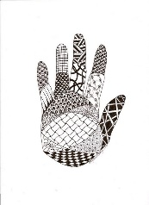  Or you could make your own zentangle ‘chatterbox’:  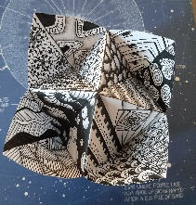  SCIENCE WITH MADDIE MOATE  This can be found on Youtube. Daily lessons that focus around a topic.  MUSIC WITH MYLEENE KLASS  This can be found on Youtube. She does lessons twice a week. Let me know what these are like. | PE with JOE WICKS  A daily work out at 9am for all the family.  YOGA  Follow an online yoga video with Cosmic Kids.  LEARN A DANCE ROUTINE WITH  OTI MABUSE  Oti Mabuse from ‘Strictly come Dancing’ and ‘The greatest Dancer’ is doing daily dance lessons for children on Youtube.  EXERCISE  www.gonoodle.com  Try this website for some motivating exercise fun.  ROCK KIDZ LIVE  A daily live sing along to some rock tunes. Lots of fun and you don’t have to be particularly tuneful!  SET YOURSELF A GOAL!  So is there anything that you can’t do now, but you want to be able to do in a few weeks? My eldest daughter wants to be able to do a handstand properly. But you might want to learn to:  *Juggle  *Practise keepy uppys with a football  *Knit/sew/crochet  *cartwheel  *solve a rubik’s cube  *learn skipping games  *learn cat’s cradle  *Cook  Let me know if you’ve learnt anything new! The more fun the better! Send in your photos. | BEETLEBOY BY M.G.LEONARD  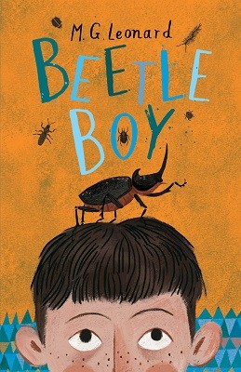  This is one of my favourite books that I read last year. I have attached the first chapter. Read it! Then choose one of the following activities:  ART - After looking at the cover and reading Chapter One, draw what you think Darkus, Uncle Max and his dad look like.  WRITE: a missing person’s poster describing key details (i.e. 5Ws - Who, what, when, where, why) of the disappearance.  If you love it (as much as I did) then you could always download the audible version for free or check out the library’s BORROWBOX service.  M.G.Leonard is a Brighton author and Beetleboy is the first in a series of her books. I think you’ll really like it. Let me know what you think!  READ EVERY DAY  Make sure you read something that you enjoy for at least 20 minutes each day. If you are struggling to find something to read, please email me.  STORYTIME WITH DAVID WALLIAMS  11am every day.
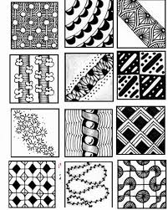
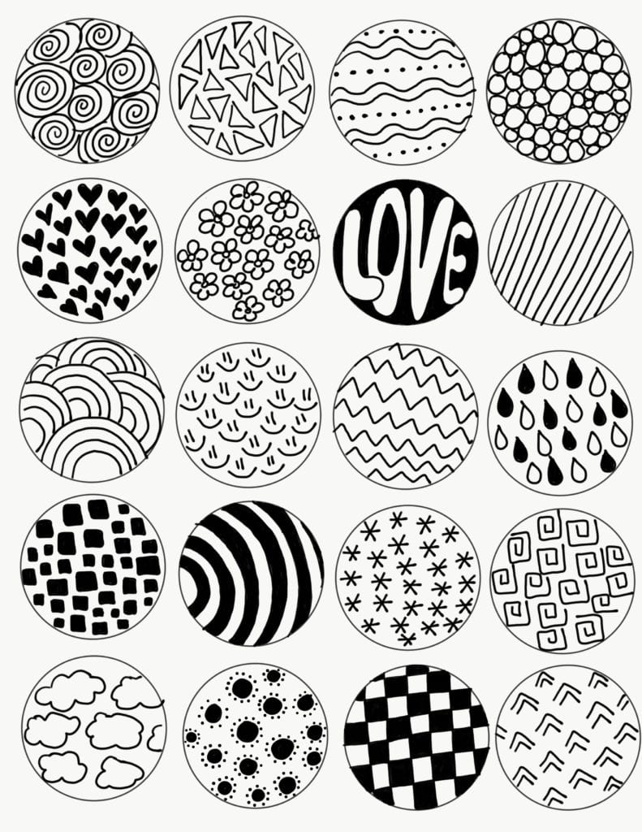
Zentangle pattern ideas

