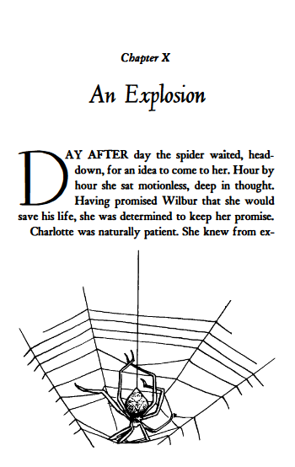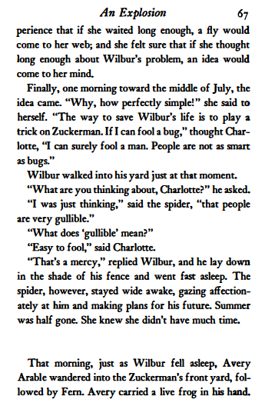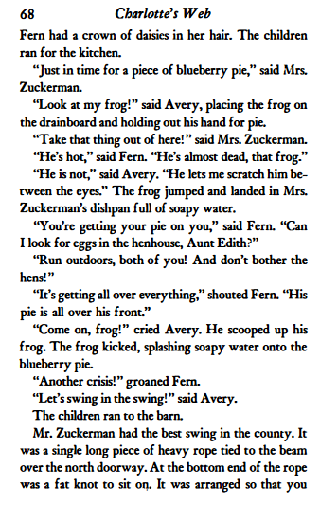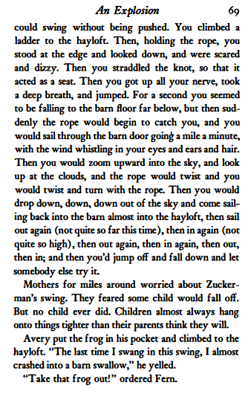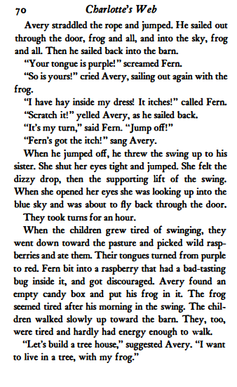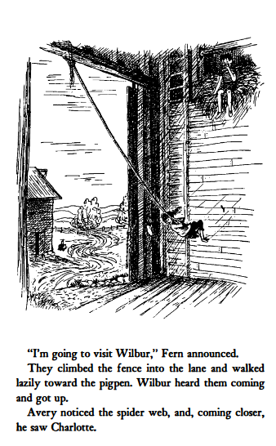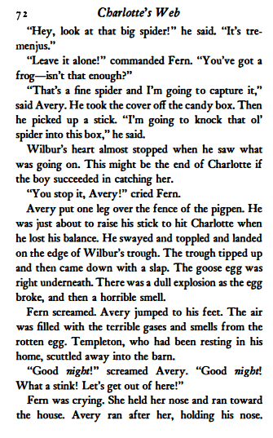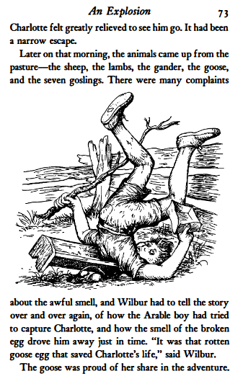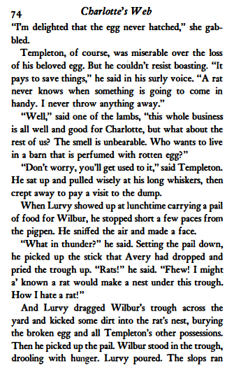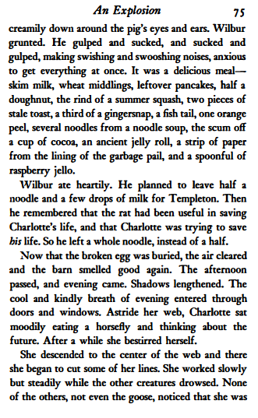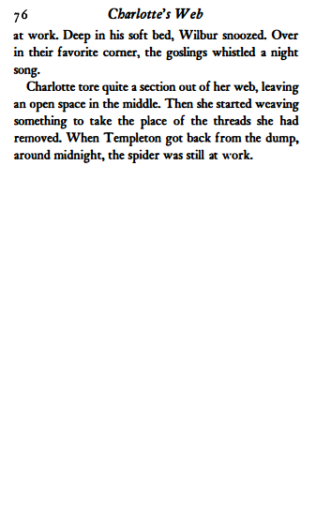

Charlotte’s Web Chapter 10: Comprehension questions
Skim and scan the text we have read this week to help you answer these questions. They are roughly in order! Answer each question with a sentence.
- What does Charlotte say the word ‘gullible’ means?
- Do you agree with Charlotte that humans are more gullible than bugs? Why?
- What words does the writer use to explain how brilliant the swing in the barn was?
- When Avery goes on the swing, who goes with him?
- Why did Avery and Fern have purple tongues?
- How did Avery try to capture Charlotte?
- How did Templeton’s egg save Charlotte?
- At the top of p.75, the writer describes the slops that Lurvy brought for Wilbur. Write down 3 more things that would make Wilbur’s slops even tastier.
- Who did Wilbur save a noodle for?
- Why do you think Charlotte has torn a section out of her web?

