Reading Task Booklet
Year 5 and 6
The Boy, the Mole, the Fox and the Horse.
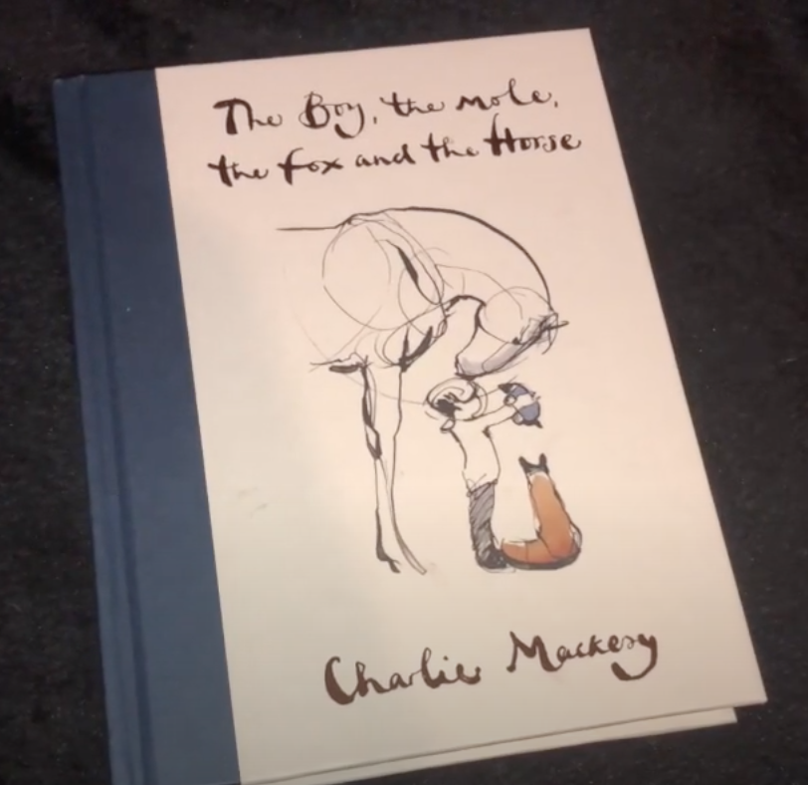

Click here to hear the story.
Day 1
For today, first listen to the story through 1 time….
Then, listen to the story again thinking about these questions as you listen
Then answer the questions:
- Why do you think the pages of this book have no numbers?

- What is different about this book to others that you have read?

- Look back over the book one more time and decide which is your favourite illustration. Say why you like this one best and what materials you think it is done with.

- Extension: Have a go at drawing one of the illustrations..

Reading Task Booklet
Year 5 and 6
Click here to hear the story.

Day 2
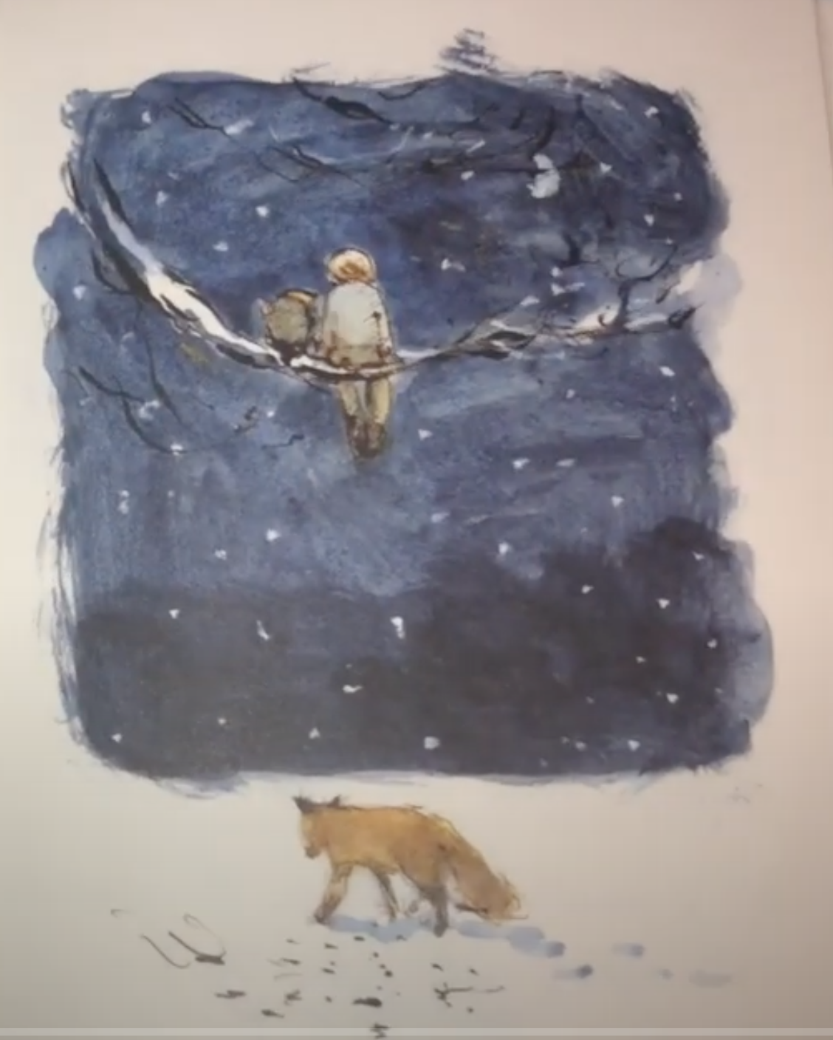
Listen to the story again, then stop at the first night time page:

- What impression do you get of the mole so far? Is he young or is he old? Give 2 pieces of evidence from the text or pictures to support your answer.

- Look closely at the night time page above… What might it seem that the fox is doing when you first see the page?

- Look at the next page on:
- What is a snare?

- Who might have wanted to capture the fox with a snare and why?

- Now let’s think about foxes….

- How many other stories can you think of with foxes in them? List them here:

- How are foxes usually portrayed in stories and why do you think they are portrayed in this way?

- What impression do you get of the fox’s character at this point in the story? Give evidence from the text or from the pictures.
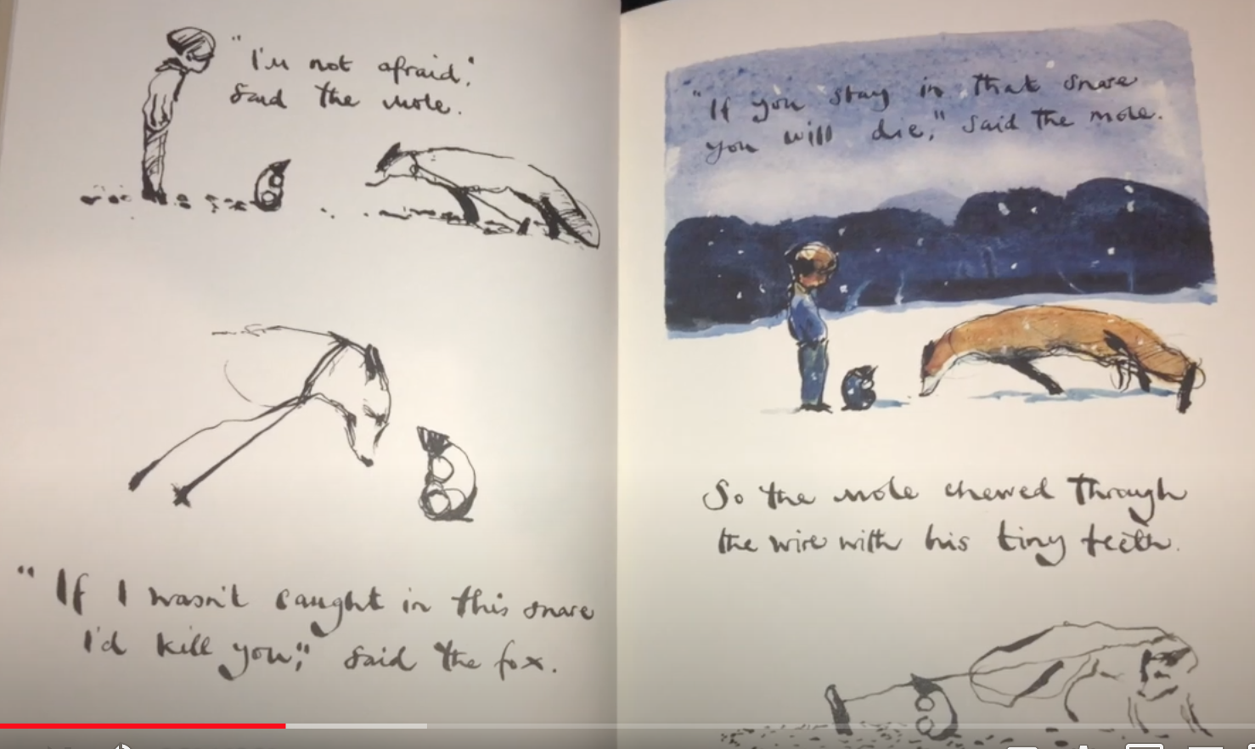

- Why will the fox die if he stays in the snare?

- Why do you think the Mole saved him?

Reading Task Booklet
Year 5 and 6
Click here to hear the story.

Day 3. Listen to the story again and stop at this page:
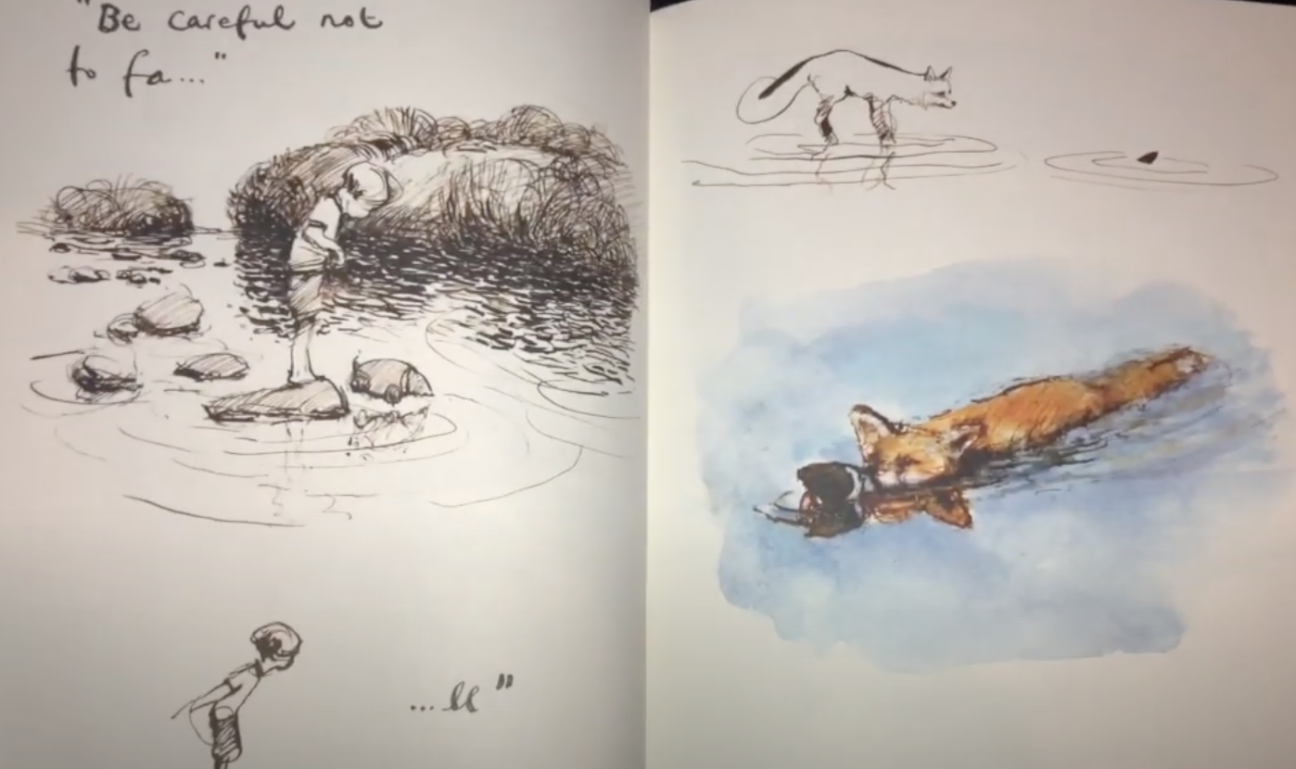

1. How and why has your view of the fox changed at this point?

2. Why do you think the fox rescued the mole?

Now go to the next page.
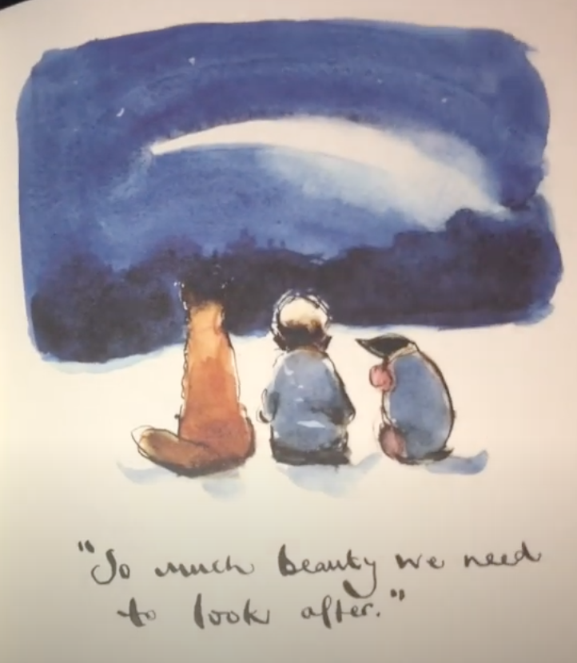

3. “So much beauty we need to look after.”
Use the next page to draw a picture of something beautiful you look after with the people that live with you in your home.
“So much beauty we need to look after.”

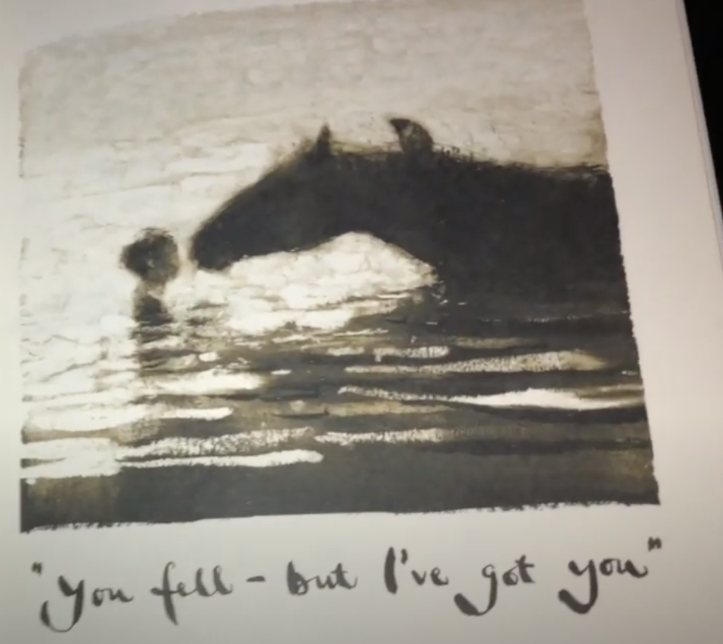
- Go to this page:

a) Who has rescued whom in the story so far?

- What is your impression of the horse’s character so far?

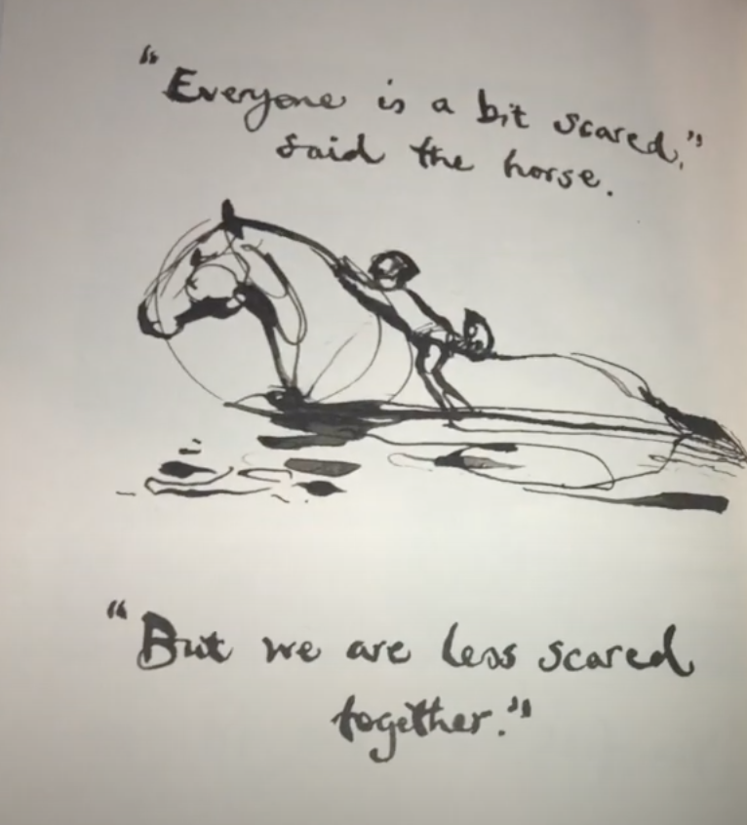
- Go to the next page:

“Everyone is a bit scared, but we are less scared together.”
- Can you think of an example of a time that you have been scared but people around you have made you feel less scared? Write it here:

Reading Task Booklet
Year 5 and 6
Click here to hear the story.

Day 4: Listen to the story again and stop at this page:
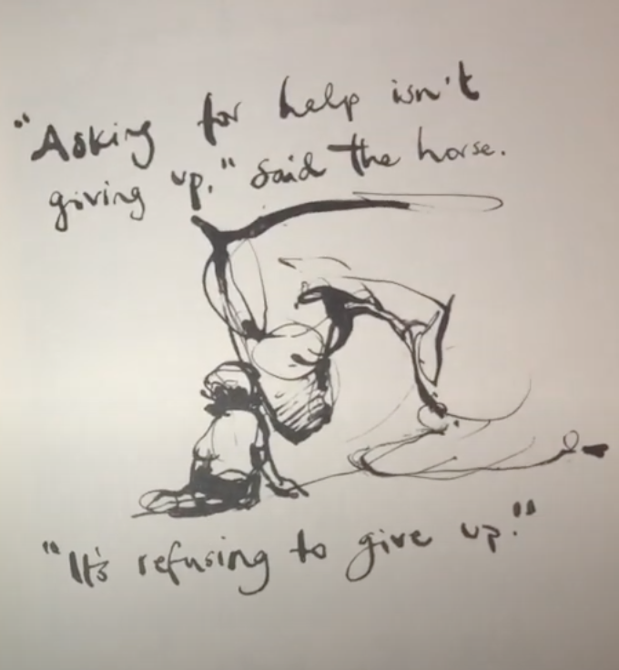

- “Asking for help isn’t giving up, it’s refusing to give up.”
How do you think this message would help us at school? Can you think of any examples? Write them here.

2. Can you use the next page to design a poster (in whatever form you want) to portray this message to help others at school when we get back?
“Asking for help isn’t giving up, it’s refusing to give up.”

Reading Task Booklet
Year 5 and 6
Click here to hear the story.

Day 5: Listen to the story again and stop at this page:
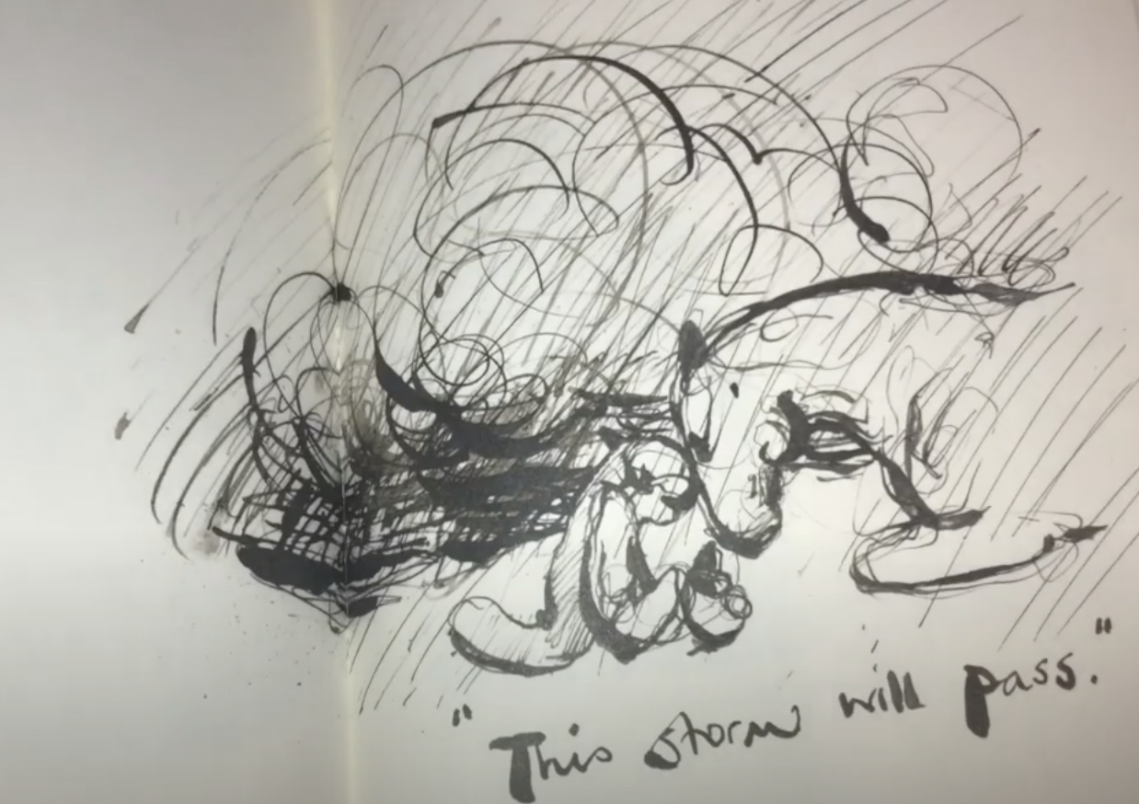

- How do you think this relates to the times we are living through now?

- Stop again at this page:
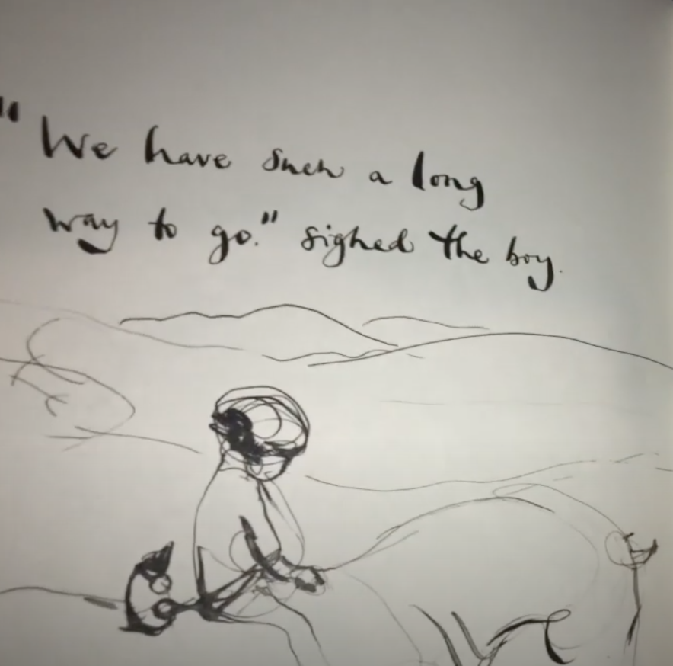

- Why do you think the Author chose the verb “sighed” to describe the way the boy spoke at this point? What does it make you think about how the character is feeling?

- Can you think of any synonyms (other verbs for speech that mean the same or similar) that would have given the same impression?

- How does the drawing of the character help to portray how the is feeling at this point?

- How do you think what the horse says helps the boy?

- Who is your favourite character in the book and why? What is the most important message that your favourite character gives in the book? Draw a picture of the character here with their message:

- The Author says this about the fox in the book:
“The fox is mainly silent and wary because he has been hurt by life.”
- Do you agree with this? How has he been hurt by life?

- How does his character change in the book and why do you think this is?

- The Author also says this about all of the characters in the book:
“They are all different, like us, and each has their own weaknesses. I can see myself in all four of them, perhaps you can too?”

a) Do you agree with this?

b) Which character do you think you are most like and why?

