[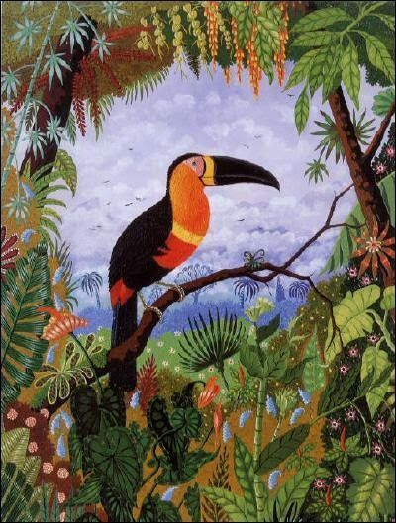](https://www.google.co.uk/url?sa=i&url=https%3A%2F%2Fwww.pinterest.com%2Fpin%2F509610514086475888%2F&psig=AOvVaw2n17qI6C_C9L0OyyHQAM2H&ust=1591638805117000&source=images&cd=vfe&ved=0CAIQjRxqFwoTCPiU_96i8OkCFQAAAAAdAAAAABAG)